OCM
Administration User guide

Table of Contents
Overview 5
Accessing Ideagen OCM 6
Logging In 6
Logging Out 6
Navigation 6
Menu Bar 6
Main Menu 6
Actions 7
Configuration Home Screen 7
User Management 8
Users 8
Users and Requestors 8
User Search 8
Adding a User Record 8
Modifying a User Record 11
User Types 11
Adding a User Type 11
User type Grade 13
Requestors 14
Adding a Requestor 14
Modifying a Requestor 15
Adding a Requestor Group 16
Modifying a Requestor Group 17
Locations 17
Adding a Location 18
Modifying a Location 18
Lookup Management 20
Disciplines 20
Modifying a Discipline 20
Specimen Types 21
Adding a Specimen Type 21
Modifying a Specimen Type 21
Associating Specimen Types with Disciplines 22
Specimen Sites 22
Adding a Specimen Site 22
Modifying a Specimen Site 23
Associating Specimen Sites with Types 23
Antibiotic Therapies 24
Adding an Antibiotic Therapy 24
Modifying an Antibiotic Therapy 24
Coded Clinical Details 24
Adding Clinical Details 24
Modifying Clinical Details 25
Patient Categories 25
Sign Off Options 26
Test Management 26
Tests 26
Adding a Test/Investigation 27
Modifying a Test/Investigation 36
View Test Associations 36
Modifying Test and Discipline Association 37
Adding and Modifying Test Containers 37
Orphaned Tests 38
Adding a Test Group 38
Modifying a Test Group 39
Test User Type Assignment 39
Sensitive Tests 40
Rules 41
Test Warnings 41
Linked Tests 41
Mutually Exclusive Tests 42
Test Guidance 42
Test Gender Constraint 43
Test Age Constraint 44
Test Clinical Detail 44
Cross Specimen Requesting 45
Test Lists 46
Personal, Location & Global Order Lists 46
Investigations 48
Personal, Location & Global Favourites 49
Request Configuration 50
Questions 50
Creating Test Questions 51
Applying Test Questions 54
Process Actions 57
Request Configuration Import/Export 62
Print Settings 63
Internet Explorer Printing 63
Advanced Printing 64
Location Print Settings 64
Machine Print Settings 69
Permissions 70
Access Permissions 70
Email 70
Notifications 71
Patient Management 73
My Patients 73
Patient Merge 73
Quick Merge 74
Patient Data Transfer 74
Change Password 78
Password Policy 79
Specimen Numbers 80
Radiology 81
Location Exams 81
Exam Permissions 81
Investigations Management 82
Adding an Investigation 82
Modifying an Investigation 83
Adding an Exam Location (Modality) 83
Modifying an Exam Location (Modality) 83
Adding an Exam Type 83
Modifying an Exam Type 83
Radiology Rules 83
Modality Warnings 83
Investigation Warnings 84
Linked Investigations 84
Mutually Exclusive Investigations 84
Test Guidance 85
Investigation Gender Constraint 85
Test Age Constraint 86
Auditing 87
Requests 87
Results 87
Confidential 87
Users 88
Sign Off 88
Notifications 89
Appendix I – Permissions Matrix 90
Auditing Permissions 90
Cardiology Permissions 90
Configuration Permissions 90
Favourite Tests Permissions 90
Laboratory Related Permissions 90
Lookup Management Permissions 91
Main Menu Permissions 91
Order Request Permissions 91
Patient Management Permissions 91
“Permissions” Permissions 92
Print Settings Permissions 92
Radiology Permissions 92
Request Config Permissions 92
Requests Permissions 92
Results Permissions 93
Standard Reports Permissions 93
Test Selection Permissions 93
Test Selection Permissions 94
User Management Permissions 94
Appendix II – LIMS Reports 95
Unsuccessful Requests 95
Successful Requests 95
Pending Requests 95

Overview
Ideagen OCM is a browser-based order communications system, developed to meet the needs of pathology and other diagnostic departments in both primary and secondary care. Ideagen OCM is compatible with all nationally recognised GP systems, providing real benefits across the range of requesting locations. The order communications system is interoperable and is proven throughout the NHS with millions of requests processed by thousands of clinicians every year.
Ideagen OCM is a diagnosis/condition-based solution which provides a single requesting process which can span multiple pathology disciplines and other investigation requests. Pre-defined order sets, requests ensure the adoption of best practice and reduce ad-hoc requesting. Clinicians are no longer expected to create an individual request for each discipline/department, reducing duplication and saving a significant amount of time.
All key clinical information is captured electronically via highly configurable, dynamic request forms. Request information is transmitted directly to the receiving department, reducing or eliminating booking in time, and preventing transcription errors.
Demand management support allows tests or investigations to be restricted to specific repeat intervals or based on other criteria such as age or gender. Orders can also be prevented by configurable rules which can help to identify inappropriate requests contraindicated by the clinical information entered, for example, through the completion of an MRI safety declaration built into the request form, or a CT request with contrast, without a recent creatinine result. These features can prevent requests being rejected at vetting and help to reduce clinical risk.
Authorised users have the ability to view test results and investigations that have been requested by other clinicians across both primary and secondary care for improved patient care. Numeric results can be reviewed in both cumulative and graphical views to assist with identifying clinically significant trends. Users can receive notifications of new or abnormal results via email and be prompted to sign off results to ensure any follow up action is carried out.

Accessing Ideagen OCM

Logging In
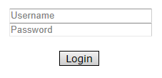
Enter your username and password at the prompt.

Logging Out
To log out of the system, click the button on the user banner.

Navigation

Menu Bar

Main Menu
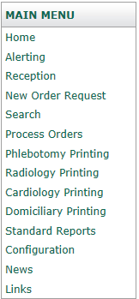
Configuration: This link takes you to a configuration section where you can customise Ideagen OCM with settings that only apply to their login.

Actions
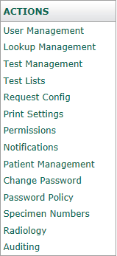
This is a dynamic menu that changes depending on the context of the current page. For example, the image on the left displays the menu options available when you click on the “Configuration” menu item.

Configuration Home Screen
Select Configuration from the Main Menu to customise Ideagen OCM.
On first selecting Configuration, you can:
- Configure your default home page
- Select whether to display print previews (not relevant for system administrators)
- Select a default orderable location
- View a list of logged in users
- Set the session expiry time
- Set the session expiry warning time
- Set password expiry
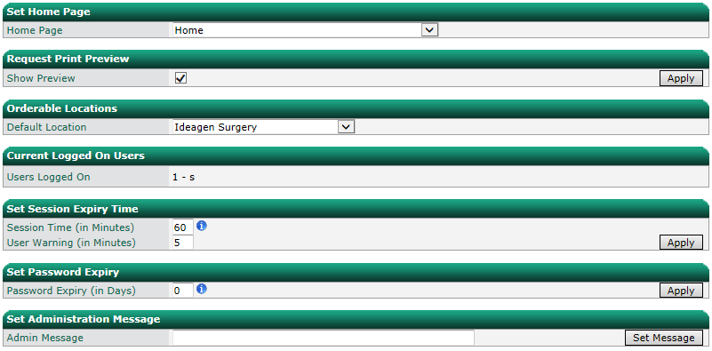
- Configure an administrators message to display at the top of the screen for any user who logs onto the system

User Management

Users

Users and Requestors
A user and requestor are two separate properties within Ideagen OCM. A user gives an individual access into the Ideagen OCM system and allows all functionality allocated to the type of user. A requestor is the details of an individual who can order requests. The requestor’s details must match the details stored in the LIMS, RIS or other departmental system. A user account can be linked to a requestor. When a user is linked to a requestor the requestor details are used to populate the requestor field with the request page when that user is logged in.

User Search
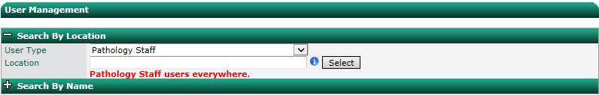
It is possible to search for existing users by type, location and by name.

Adding a User Record
Existing users are displayed in a user list. Select an existing user or enter details into the blank fields to create a new user.
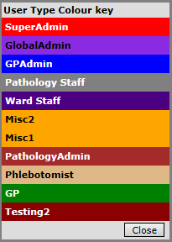
Users within the list are colour coded depending on the user type. Clicking the blue ‘i’ will show a popup with a table showing the colour key, for example:

To add a new user to the system, complete the mandatory fields:
- First Name
- Last name
- User Name
- Passwords
- User Type – used to assign permissions
- Home Page – default home page
- Locations – locations for which the user is able to make requests
- Requestor – associated requestor (if the user is a requestor, or they always make requests on behalf of the same requestor)
Any non-mandatory fields as required:
- Email Address
- Description – free text description for the user
- National code – national GP code
- Clinical System Username – usernames from third party clinical systems such as GP practice system, clinical portal or EPR to be mapped to this user when Ideagen OCM is launched
- Grade – staff grade
- Bleep number
- Requestor Groups – filters results/reports when signing off to ensure the whole of a team/group is made aware of the presence of a result
- Location Groups – associates the user with all locations within the location group
- View Sensitive Results – allows user to see results marked as sensitive (E.G. GUM results)
Users with this permission will be able to view results for sensitive tests regardless of whether they requested the tests or not. If they view a request for a patient, they will see that sensitive tests have been requested for the patient regardless of whether they are the creator of the request.
Users without this permission will only be able to view results for sensitive tests only if they were the original requestor of the tests. If they view a request for a patient, they will see that sensitive tests have been requested for the patient only if they are the original requestor of the tests.
- Locked – lock/deactivate user account
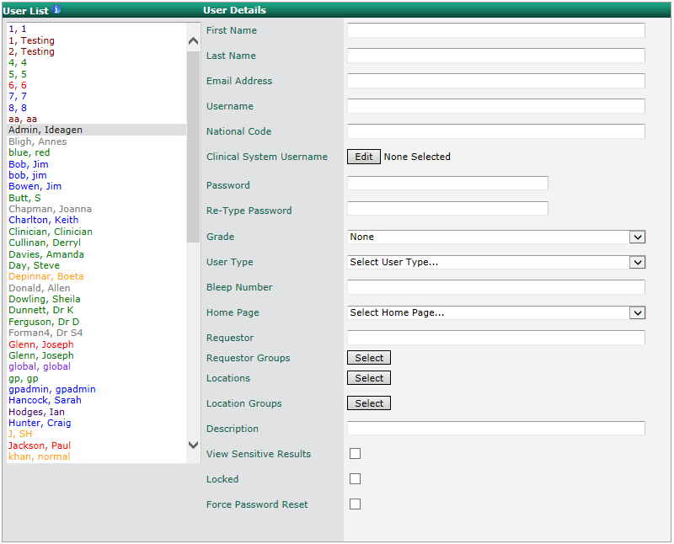
- Force Password Reset – forces the user to reset their password on first login

If an existing user’s details are in these fields click Clear All before entering the new user’s details. The location field has auto complete functionality.
To begin, specify the first name and last name of the user. After focus is lost from the last name field the system will automatically create an unused user name. If AUser was already in the system then AUser1 would have been used. A random password which meets the current password policy is also created.
If the user needs to know their password (if they will need to access the system directly rather than launching from a clinical system), then the auto generated password will need to be over written. As you type the system will indicate how strong the password is and what characters are required to meet the password policy. If the entered password does not meet the password policy, the user will not be saved.
Click Add/Update User to save the new user to the system. The user name and password entered here will be used by the user when logging into Ideagen OCM.

Modifying a User Record
To modify the details of an existing user, select the user, make the required changes and click Add/Update User.
The password fields are initially blank. If a password change is required enter the new password into the fields. If a password change is not required, leave the password fields blank and the password will remain unchanged.
Click Remove User to delete a user from the system.

User Types
Users can be grouped together using User Types. This allows for easier management of Ideagen OCM. Many configuration options, for example test and page permissions, are specified at the User Type level.

Adding a User Type
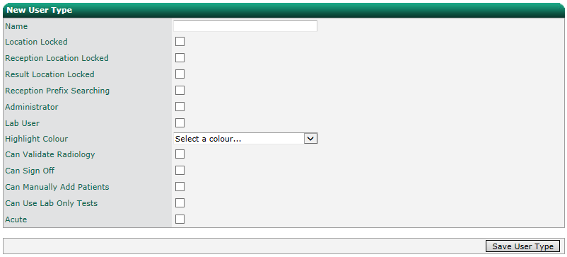
Within the User Types screen, you can add and edit user types. To add a new user type, enter a name, configure the properties, and click Save User Type.

Fields:
- Location Locked – Locks the user to one location at a time. For example, the Search screen. A Location Locked user will be locked to their current default location.
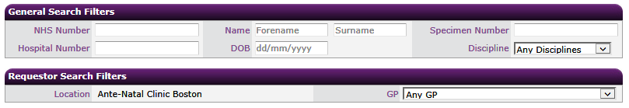
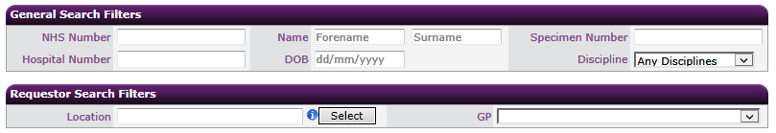
A user without a locked location defaults to all locations. They can filter by any location by typing and selecting the location in the Location text field.

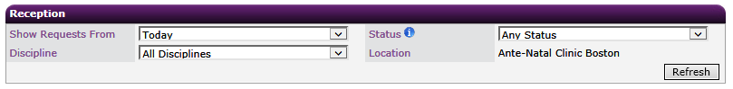
- Reception Location Locked – Similar to the Location Locked property, but specifically for the Reception screen. A Reception Location Locked user will be locked to their current default location.

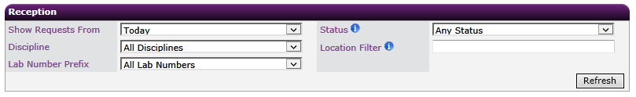
A user not locked to a reception location defaults to all locations. They can filter by any location by typing and selecting the location in the text field.

- Result Location Locked – A user who is Result Location Locked will only be able to view a patient’s results requested from their current default location. A user who isn’t locked to a result location will be able to see all a patient’s results regardless of the requesting location.
- Reception Prefix Searching – obsolete – do not use.
- Administrator – Gives the users additional privileges to allow them to administer Ideagen OCM. For example, the Test Management screen. If a user type is created without the Administrator flag and given access to the Test Management screen, they will see:

If the same user type is given the Administrator flag they will see:

- Lab User – Gives users additional privileges to allow them to use Ideagen OCM. For example, the Cancel button for a request becomes a Reject button. Lab Users can also reinstate a cancelled/rejected request, and add tests to a request that has already been collected.
- Highlight Colour – Highlight colour used in the User Management screen.
- Can Validate Radiology – Basic flag to allow the users to validate radiology requests. If this flag is not set the users cannot validate the request and they have to get someone who can. If any exam permissions are configured via the Exam Permissions screen, this flag is ignored. The Exam Permissions screen gives precise control over who can view\validate each exam.
- Can Sign Off – Gives users the result sign off functionality. Users without this flag will not see the Sign Off or Sign Off Audit buttons when viewing results.
- Can Manually Add Patients – Allows users to manually add patients if they don’t already exist in Ideagen OCM.
- Can Use Lab Only Tests – Allows users to add tests that are marked for lab use only.
- Acute – acute flag used for messaging
To edit a User Type select it from the User Types drop down, modify the properties and click Save Changes.
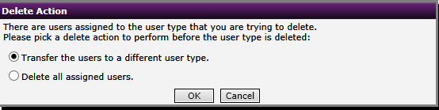
To delete a User Type, select it from the User Types drop down, modify the properties and click Delete User Type. If there are no users assigned to this user type it will be deleted. If there are users assigned, a warning will be displayed.

Select the desired option and click OK.

User type Grade
User Type Grade is used to rank the user types so in certain screens the users can't see/administer users in a user type with a higher grade.
The hierarchy can be altered by dragging and dropping the user types into the desired order. Once dropped the hierarchy is automatically saved.

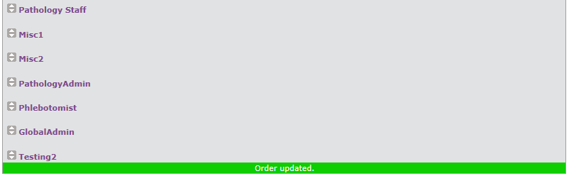

Requestors
When making requests, the request must be assigned a valid requestor for it to be submitted to the LIMS, RIS or other departmental system. The requestors within Ideagen OCM must match the requestors in the remote system. If the codes do not match the request will fail when submitted to the system.
Requestors are configured during original setup to specifications supplied.

Adding a Requestor
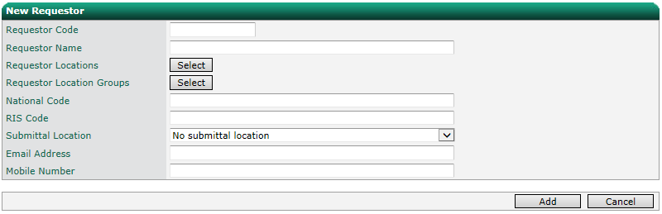
Within the Requestors screen you can add and edit requestors. To add a new requestor, enter the code and name of the new requestor.

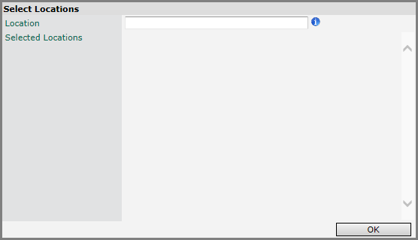
A requestor can be linked to one or more individual locations and to predefined location groups. To add the requestor to an individual location and specify the default location click on the Select button next to Requestor Locations.

In the location field start typing the name of the location that the requestor will be linked to. A drop down list will appear with valid locations that the requestor can be linked to. Select the correct location and tab or click away from the locations field. The location will be added to the list of selected locations for the new requestor.
Select all the locations the requestor is associated with and click OK. A default location is mandatory. The user can change their default location when they are logged into the system.
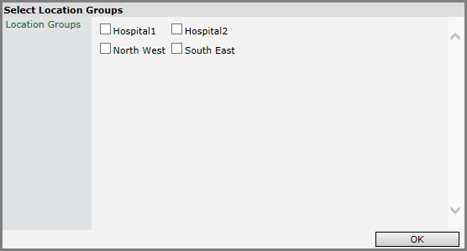
To add the requestor to one or more location groups, click on the Select button next to Requestor Location Groups.

Select all the location groups the requestor will be allowed to order from and click OK.
Enter the requestors national (GP or GMC) code, RIS code (as this may be different to their requestor code), email address and mobile number.
If your system is configured for multiple submittal locations the ‘Submittal Location’ dropdown will be enabled and you can choose which site the requestor will be submitting requests to.
If your system isn’t setup for multiple submittal locations the drop down will be disabled.
Click Add to add the new requestor or Cancel to clear the fields.

Modifying a Requestor
To edit or delete a requestor, select the location by typing the location name into the location field. The auto complete function will show a drop down of valid location names to help with the location selection. Select the location which will populate the requestor drop down with the requestors at the selected location. Select the requestor from the drop down list.
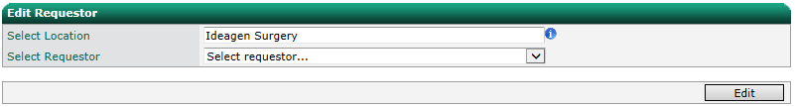

As soon as a requestor is selected the details will be loaded.
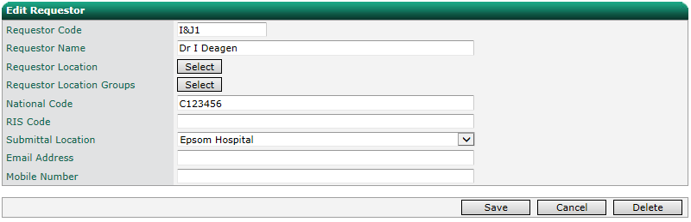

Alternatively, if the requestor is proving hard to find, the requestor can be searched in the Find Requestor section.
As the requestor name is typed a drop down will appear with matching requestors.

Selecting a requestor from the drop down will load it into the Edit Requestor section.
Amend the properties of the requestor and click Save to save the changes to the system or click Cancel to cancel the changes.
To delete the requestor click Delete. A requestor is not removed from the system completely, but marked as inactive. To reactive a requestor, select the requestor in the Inactive Requestors section.
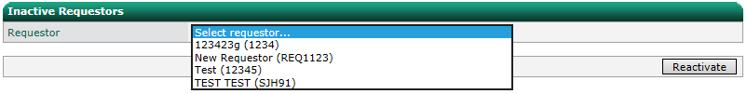

Click Reactivate to make the requestor active again.

Adding a Requestor Group
Requestors can be grouped together by job function, location, or any other logical reason. Once created, the requestor group can be used as a permissions object i.e. the same way a user or user group can be given permissions to a certain action or location.
To create a new requestor group, enter a name and click Select to choose the requestors.
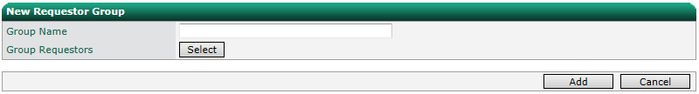

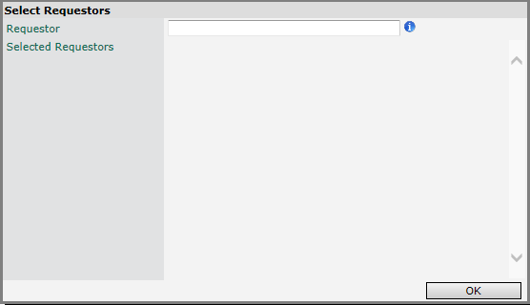
Start typing the name of the requestor and matching names will appear in a drop down. Selecting the requestor from the drop down will add them to the group.

Select all the requestors to add to the group and click OK. Click Add to add the new requestor group.

Modifying a Requestor Group
To edit a group, select it in the Edit Requestor Group section.
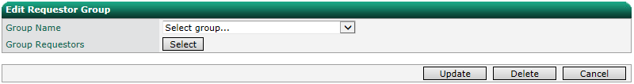

Click Select to open the selection popup. To remove a requestor, uncheck their checkbox. To add a new requestor, search for them by typing their name in the Requestor text box.
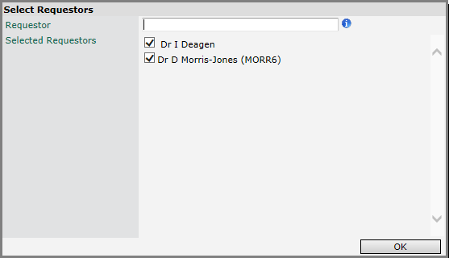

Click OK then Update to save changes.

Locations
When making requests within Ideagen OCM, the request must be assigned a valid location for it to be submitted to the LIMS, RIS or other departmental system. The locations within Ideagen OCM must match the locations in the remote system. If the codes do not match the request will fail when submitted to the system.

Adding a Location
To add a new location, enter the code, name, and location type (GP, Inpatient, Outpatient or A&E) for the new location.
Enter the locations national and RIS codes if applicable.
If there are any PCTs configured the location can be linked to the PCT which the location is in.
If there are any hospitals configured the location can be linked to the hospital which the location usually sends its requests to.
Enter the telephone number for the location.
Note – phlebotomy clinic is obsolete – do not use.
In the IP fields enter the IP address range that the location uses for its computers. When a user connects to Ideagen OCM via LabelTrace the IP address of the connecting machine is checked to see if it is within the range stored within the system.
If the IP address falls outside of this range they are not automatically logged in and are taken to the login screen where they must manually log in. To enable domiciliary requests to be created from this location check the Domiciliary Enabled checkbox. Change the default patient categories for any of the disciplines if required (see Patient Categories Management for details on how these are configured).
The default patient category affects which patient category is initially selected on the request screen.
Tick the “Is GP” box if the location is a GP practice.
Select the default patient categories that will be used when ordering for all available diagnostic disciplines.
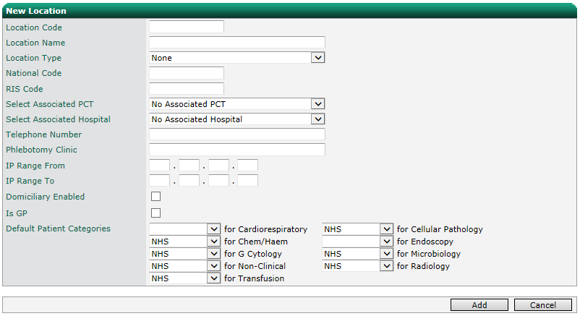
Click Add to add the location to the system or click Cancel to cancel the action.

Modifying a Location
To edit a location, start typing the location name into the ‘Select Location’ field. The auto complete function will populate a drop down of valid locations as you type.
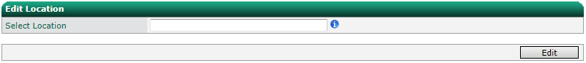

Select the required location from the drop down and click Select. Click Edit to edit the location.
Amend the properties of the location and click Update to save the changes to the system or click Cancel to cancel the action.
Click Delete to delete the location. The location is not removed from the system but is marked inactive. To reinstate a location, select it from the inactive locations drop down and click Reactivate.

Lookup Management
For a test to be visible on the order screen for a selected discipline, type and site combination, the test has to be associated with the discipline, type and site in the combination. This relationship is shown below:
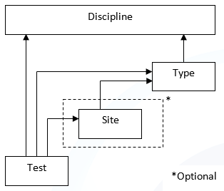
Tests are linked to disciplines and types. If relevant, tests can be linked to a sample site too. Sites are linked to sample types and types are linked to disciplines. There are four management pages that allow the configuration of disciplines, types, sites, tests and their relationships.

Disciplines

Modifying a Discipline
Select a discipline from the drop down list, modify the properties and click Save Changes or click Delete Discipline to remove it from the system. When a discipline is associated with one or more specimen type, a default one can be set. The default specimen type will be automatically selected when the you select the discipline from the drop down on the request form.
Fields:
- Show Specimen Sites – allows users to filter tests by specimen site
- Allow Specimen Collection – for disciplines where a sample is collected, E.G. blood sciences and microbiology, but not radiology
- Request Tests Header – header to display at the top of the individual requesting screen, post order
- Allow “Add Test” Options – allow the addition of tests to an order not included in the users favourite tests lists
- Allow Rejecting – displays a Reject button for users when viewing a request, post order
- Send Reject Message – when user clicks the Reject button described above, send a reject notification to the departmental system
- Allow Cancelling - displays a Cancel button for users when viewing a request, post order
- Send Cancel Message - when user clicks the Cancel button described above, send a cancellation notification to the departmental system
- Allow Standalone Ordering – obsolete – do not use
- Allow DBO Ordering – this should always be ticked when using Ideagen OCM version 3.x
- Notification Triggers – linked to the Notifications capability of Ideagen OCM (see Notifications section). Allows you to set which statuses will trigger an email or SMS notification the requestor for the discipline.
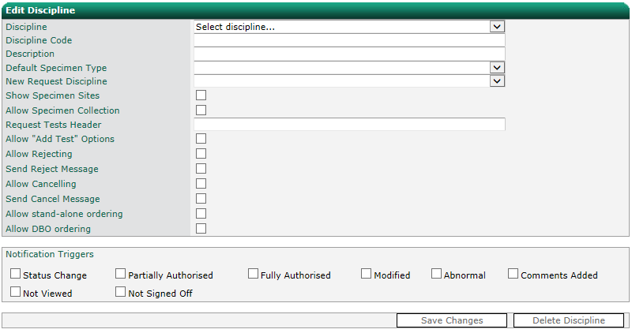
Some disciplines are built in to the system and cannot be deleted, but can be modified.
Note – it is not possible for system administrators to add disciplines as this affects licensing. If you require an additional diagnostic discipline, please contact your Account Manager.

Specimen Types
The specimen types screen allows you to add, modify and delete specimen types, and associate them with disciplines.

Adding a Specimen Type
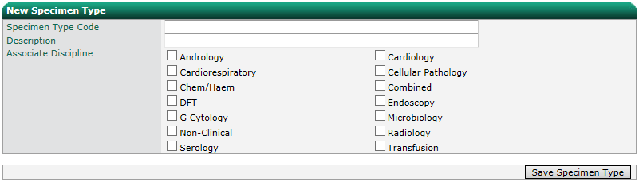
To add a new specimen type, enter a code and description, select the associated disciplines and click Save Specimen Type.

Modifying a Specimen Type
To modify a specimen type, select it from the drop down list. To filter the list, first select a discipline. You can then modify the code, description, default specimen site, default specimen container, and whether a phlebotomist can collect this type of specimen. Click Save Specimen Type to save changes or Delete Specimen Type to remove the specimen type from the system.

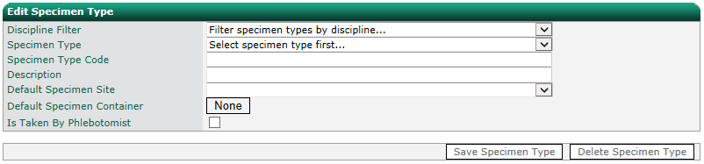

Associating Specimen Types with Disciplines
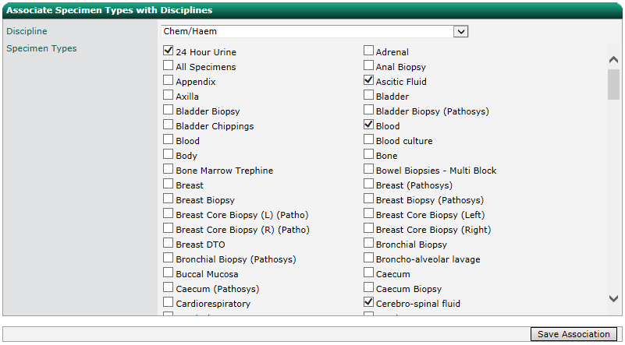
For ease of use, it is also possible to select a discipline, and select all its associated specimen types. Click Save Association to save any changes.

Specimen Sites
The specimen sites screen allows you to add, modify and delete specimen sites, and associate them with specimen types.

Adding a Specimen Site
To add a new specimen site, enter a code, description, and specimen site type, select the associated specimen types and click Save Specimen Site. To filter the list, first select a discipline.
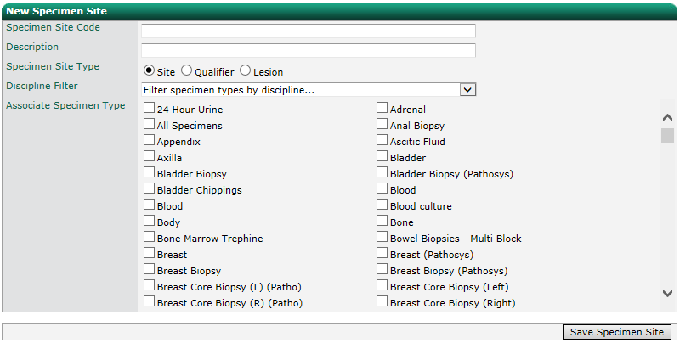
Note – the site type may not be relevant to your implementation, if so, you don’t need to select an option.

Modifying a Specimen Site
To modify a specimen site, select it from the drop down list. To filter the list, first select a discipline and specimen type. You can then modify the code and description, and specimen site type. Click Save Specimen Site to save changes or Delete Specimen Site to remove the specimen site from the system.
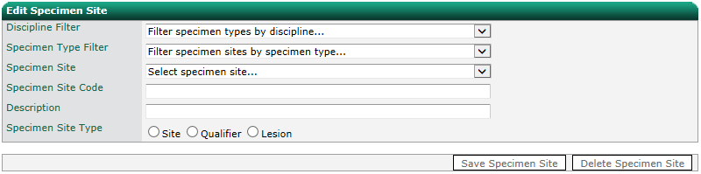
Note – specimen site type is obsolete - do not use.

Associating Specimen Sites with Types
For ease of use, it is also possible to select a discipline, and select all its associated specimen types. To filter the list, first select a discipline. Click Save Association to save any changes.
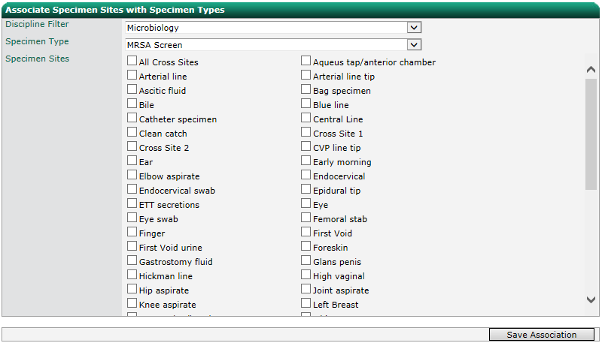

Antibiotic Therapies

Adding an Antibiotic Therapy
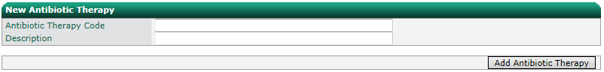
To add a new antibiotic therapy, enter a code and click Add Antibiotic Therapy.

Modifying an Antibiotic Therapy
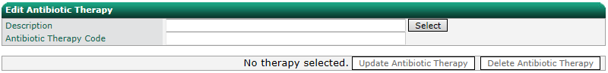
To modify an existing antibiotic therapy, start typing its description in the ‘Description’ field. A drop down will appear as you type showing valid therapies based on the text typed. Click on the required name from the drop down and then click Select. You can then modify the code and description. Click Update Antibiotic Therapy to save changes or Delete Antibiotic Therapy to remove the antibiotic therapy from the system.

Coded Clinical Details
Users can add pre-defined clinical details when they create a new order. The associated codes should match those in the receiving system such as LIMS, RIS or other departmental system.

Adding Clinical Details
To add a new coded clinical details record, enter a code, description, select the associated disciplines, mark the clinical details as fasting or non-fasting, and click Add Clinical Code.
The two properties ‘Is Fasting’ and ‘Is Non Fasting’ are used for the test triggered clinical details. They are used to inform the system that the particular clinical detail indicates the patient was either fasting or not fasting.
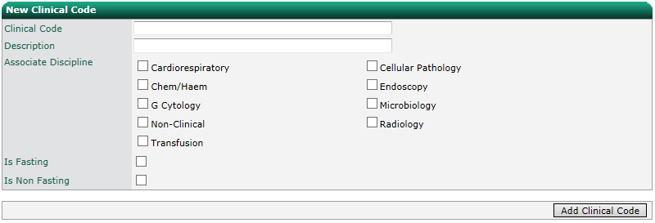

Modifying Clinical Details
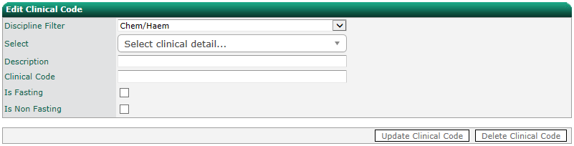
To modify a coded clinical details record, select it from the drop down list. To filter the list, first select a discipline. You can then modify the code, description, and mark the clinical details as fasting or non-fasting. Click Update Clinical Code to save changes or Delete Clinical Code to remove the coded clinical details record from the system.

Patient Categories
Patient categories are specified per discipline. They are displayed on the relevant request screen via a drop down list. A location can be configured to have a default patient category per discipline (see the Location Management section).
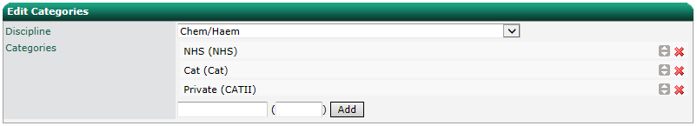
To add a new patient category, select a discipline and enter a description and code, and click Add.

The order that they appear in the list is the order that they appear in the drop down on the request form. To change the order in which they appear in the list hold the button and drag to the desired position.
To delete a patient category from a discipline, click the button.

Sign Off Options
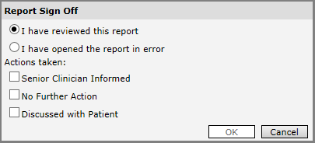
Sign off options are displayed when a user attempts to sign off diagnostic results.

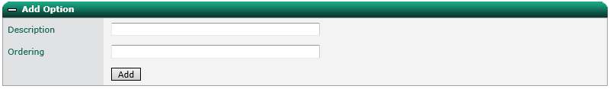
To add a new option, enter a description and a number to denote the order that the options will be displayed. Click Add to save.

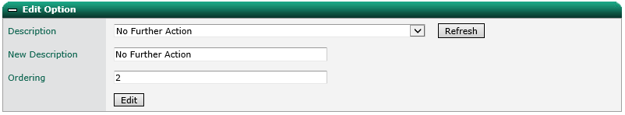
To edit an option, select the description from the drop down list and update the description and ordering. Click Edit to save changes.

To delete an option, select the description from the drop down list and click Delete to delete.
The current options, including the display order, is displayed at the bottom of the other panels.

Test Management

Tests
The tests screen allows you to add, modify and delete tests/investigations, and associate them with specimen sites and types and disciplines.

Adding a Test/Investigation
Note – Radiology examinations can be added by selecting the “Investigation Management” option from the Radiology Menu.
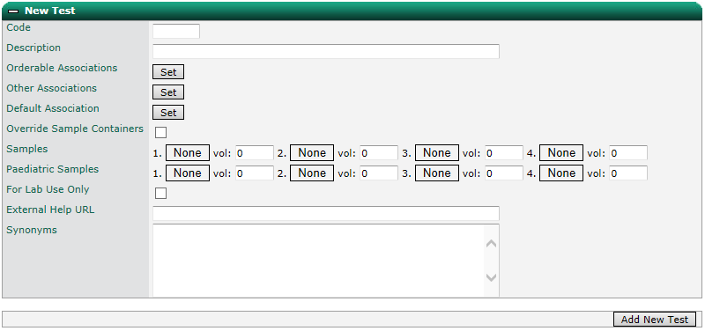
To add a new test, enter a code and description.

Select Orderable Associations to configure which diagnostic disciplines the test will be linked to. Orderable Associations are the discipline/type/site combinations that the test can be sent to the LIMS with and the LIMS will not reject the order. For example, a Full Blood Count test can have an orderable association with Blood Sciences/Blood, but not Microbiology/Urine/Mid-Stream.
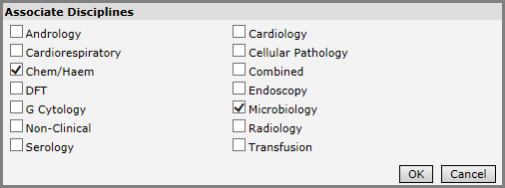
Note – Orderable Associations are only relevant for Pathology tests.

Select the associations and click OK. Next select the associated specimen types and click OK.
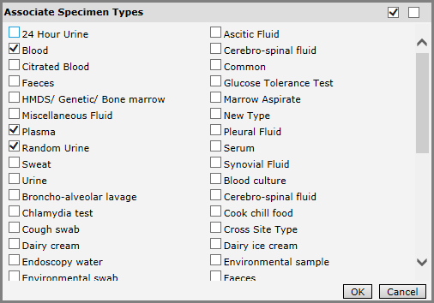
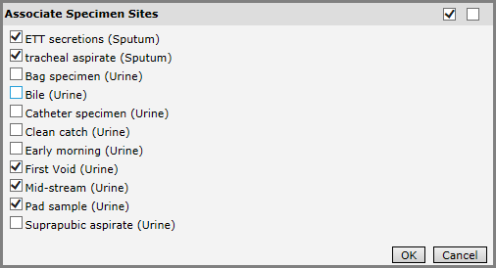
Finally, if there are any specimen sites linked to the specimen types you selected, select the associated specimen sites and click OK.

If required, the test can be configured to show under other discipline/type/site combinations using Other Associations. The selection process is the same as for Orderable Associations.
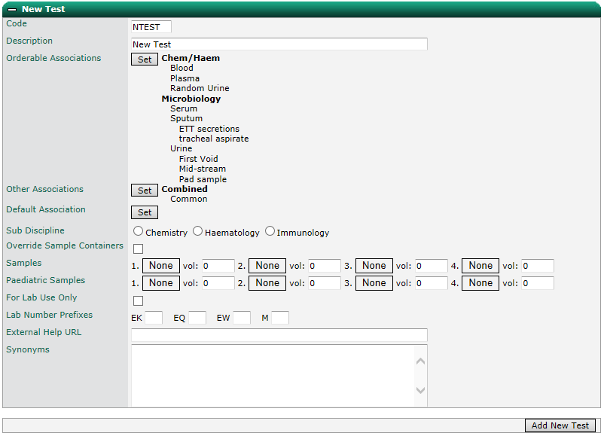
The test will now be available when the user creates a combined/common request. However, if Ideagen OCM tried to send this test to the LIMS with combined/common, LIMS would reject it. Prior to sending to the LIMS, the system needs to move the test onto an Orderable Association. To help this the test needs to be given a Default Association. Click Set next to Default Associations, select the default, and click OK.
Note – sub discipline and sample container override are obsolete – do not use.
Configure the sample container(s) required for the test (if applicable) by clicking on the first box marked “None” and selecting a colour. These colours will be displayed on in the order basket when a new order is created, and when processing an order (E.G. at sample collection).
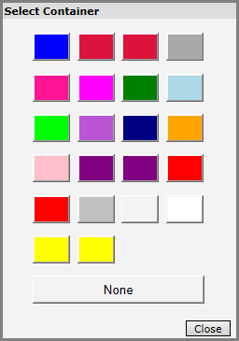
Enter a volume for each container selected. This volume can be any decimal number and can be bigger that the max volume of the selected container. For example, if you select a container with a maximum volume of 100 and added a sample volume of 200, at the time of collection the system will advise the user to use 2 containers to fully accommodate the sample volumes.
When a user is collecting the samples for a test request, the system will take into account the sample containers used by each selected test and combine each sample that uses the same sample container. The system will use the maximum volume of the container, and the total sample volume to determine how many of each container is required.
Paediatric samples can be specified when adding or editing a test. They are configured in the same way as standard samples.
They are used instead of the standard samples on a request when the patient’s age is less than the paediatric threshold age value in the system settings. At the time of specimen collection, the tube guidance will show the sample containers chosen for paediatrics patients.
If the test should only be added by the laboratory, tick “For Lab Use Only”. The test will not be visible for users without the “Can Use Lab Only Tests” permission selected for their User Type.
Lab Number Prefixes can be used to specify the prefix the lab number should have for this test. These settings are only required for particular implementations and are part of the wider Lab Number logic.
Each test can be given an External Help URL. When specified, a icon appears next to the test in the order basket on the order screen. Clicking the icon launches the URL in a separate window.
On the order screen the filter functionality is used to find tests by typing the test name or part of the test name. It will also search test synonyms. A test’s synonyms can be specified via Synonym field, one line per synonym.
Click Add New Test to add it to the system.

Detailed Explanation of “Other Associations”
Other Associations allow a test to appear under discipline/type/site combinations other than those it’s supposed to be associated with. This functionality works well for tests commonly ordered at the same time, but span different disciplines, types and/or sites. For example, if you have 3 tests commonly ordered together, but they are associated to three different specimen types they can be configured to appear under a common specimen type. This allows them to be requested all at the same time without manually creating 3 separate requests from the start. At some point in the life of the request, depending on various configurable options, the request will be automatically split into three distinct requests and the correct specimen types assigned ready for submittal.
The behaviour can be illustrated with the following two tests.
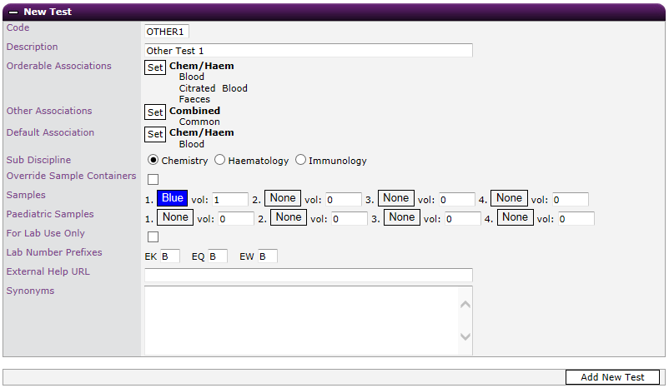
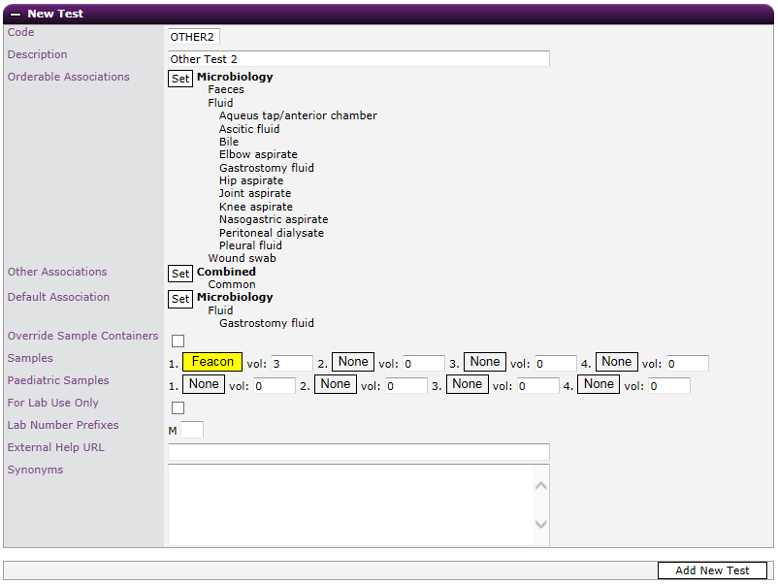
Both tests are orderable on different disciplines. However, they have been configured to show under Combined/Common.
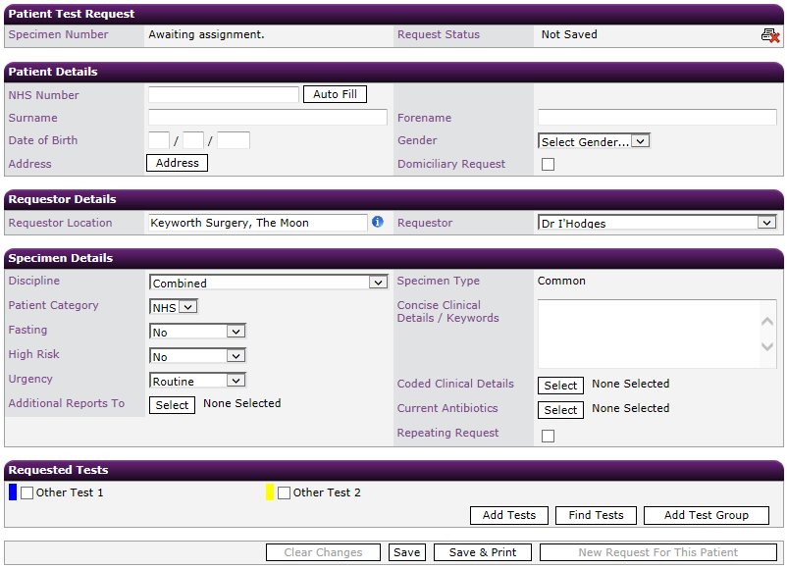
Via Discipline Management I have configured the Combined discipline to split on Save and to confirm the final discipline/type/site of the tests.
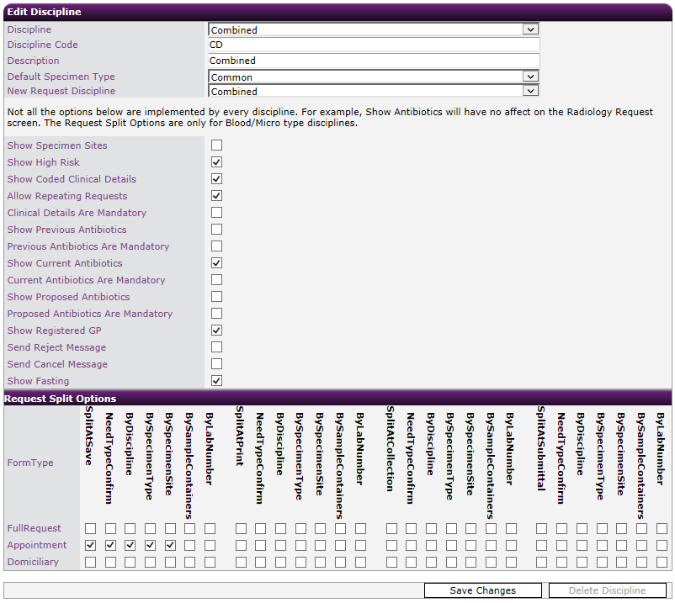

When saving a new request with both tests selected a popup will appear asking for confirmation as to which association the tests should be moved to.

The associations for each test are preselected to the default association specified via the Test Management screen. If different, the user can change these to the correct association for the sample. If only one orderable association exists for a test the user will not be prompted to confirm for that particular one. Alternatively the prompt can be turned off in the Discipline Management screen. In this case the user is never prompted and all the associations are changed to their default.

Once confirmed the request is split into two.
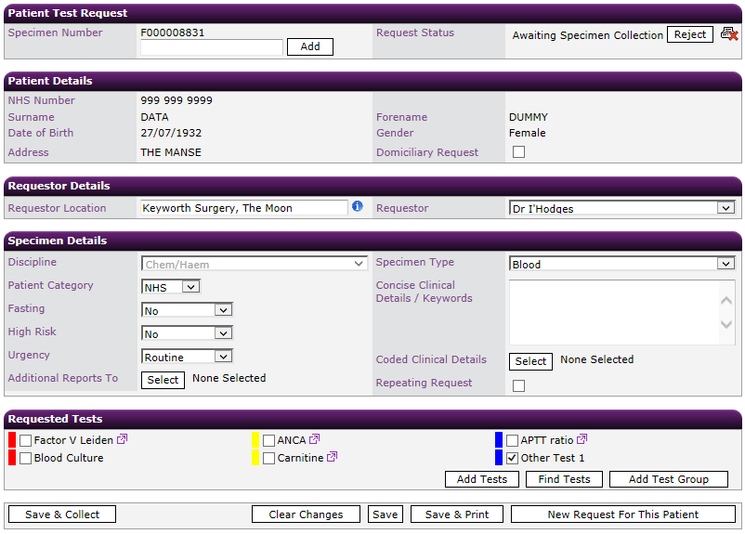
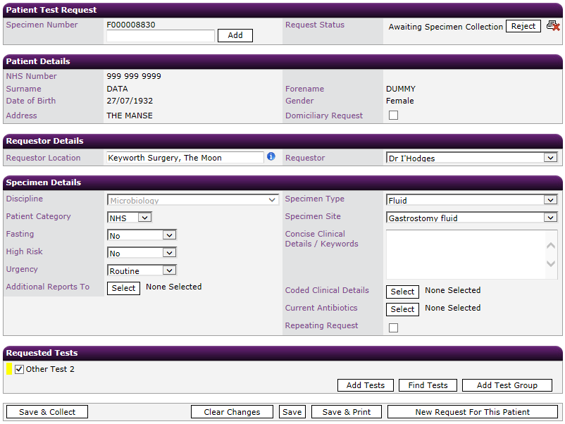

Via the Discipline Management screen the point at which a request is split and the splitting criteria can be tailored per discipline.

Modifying a Test/Investigation
To modify a test, select it from the drop-down list. To filter the list, first select a discipline and specimen type. You can then modify all the settings for the test. Click Save Changes to save changes or Delete Test to remove the test from the system.

View Test Associations
For ease of use, it is possible to view a hierarchy of tests, sample types and disciplines in View Test Associations area. Click an item in the hierarchy to expand. Double click an item to expand all its sub items. Click Reset to collapse the hierarchy.
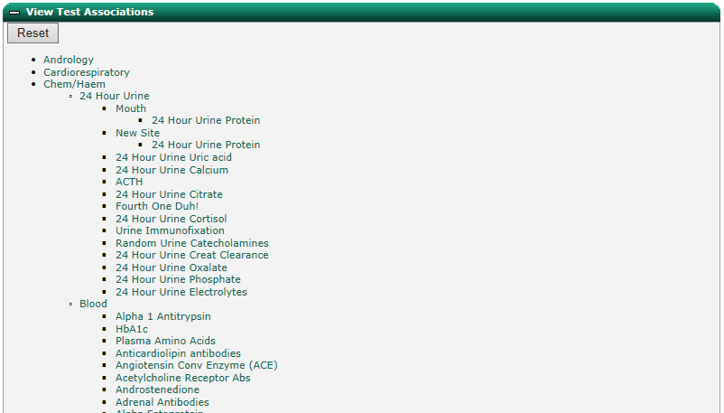

Modifying Test and Discipline Association
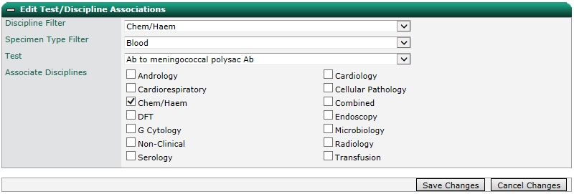
To modify the discipline a test is associated with, select a test from the drop-down list. To filter the list, first select a discipline and specimen type. Select the associated disciplines and click Save Changes to save changes or Cancel Changes to cancel.

Note – if a new test was removed from Blood Sciences it would no longer appear for a Blood Sciences request even if still associated with a Blood Sciences specimen type. Click Save Changes to save the new associations. Once the test has been associated with a new discipline it will require editing to link it to the required specimen types and sites.

Adding and Modifying Test Containers
When configuring tests in Ideagen OCM, you can specify the exact sample volume that needs to be collected. This works in conjunction with the ability to set sample container max volume values. These two values can then be used by the system when providing test container guidance to the user by calculating how many physical containers are needed based on the container max volume and total volume of sample required.
Test sample containers can be configured in the “Edit Test Containers” panel within the Tests configuration area.
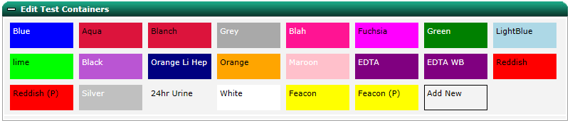
Coloured blocks that represent test containers stored in the system will be displayed.

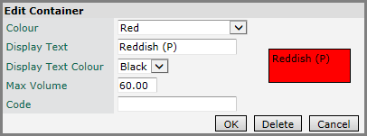
Either click Add New to add a new container or select an existing container to edit the configuration including colour, display text, text colour, maximum volume, and code. Click OK to save changes, Delete to delete the test container, or Cancel to cancel changes.

Orphaned Tests
It is possible for a test to become ‘Orphaned’. For example, a test is linked to a single discipline and that discipline is deleted. Expand the ‘Orphaned Tests’ panel and select the test from the drop down. Select which discipline to link the test to and click Save Associations. The test can now be edited in the ‘Edit Test’ panel.
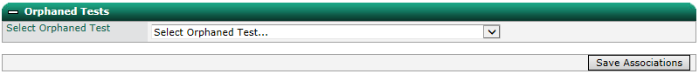

Adding a Test Group
To add a test group, enter a name and select a discipline and specimen type. Select a location and/or location groups for which the test group will be available or select all locations.
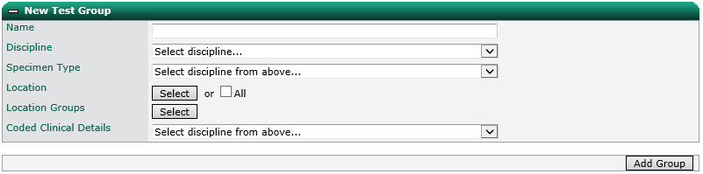

Select a coded clinical detail if required and click Add Group.
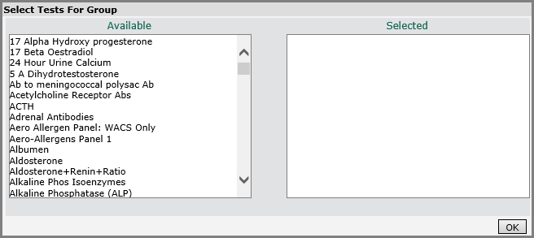
Add tests to the group by double clicking the entry in the Available list. To remove, double click the entry in the Selected list. Click OK to save.

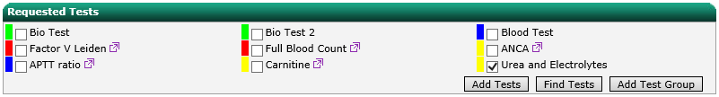
Note – test groups are currently only available from the individual request screens that are displayed after the original order has been submitted, for example, when editing the original request.

Modifying a Test Group
To modify a test group, select a test group from the drop down list. Change the name, locations and coded clinical details as required and click Update Group. Update the tests in the group and click OK to save.

Test User Type Assignment
The availability of tests to users of a particular user type can be managed via the Test User Type Assignment screen.
Select a user type, then a discipline from the drop-down lists.
Note - by default, all tests across all disciplines are unchecked for a user type. This means that the user will have access to all tests, the same effect as ticking all tests.
Ticking one or more tests will mean users of that user type will only have access to request the selected tests.
Click the buttons at the top right of the screen to select and deselect all tests.
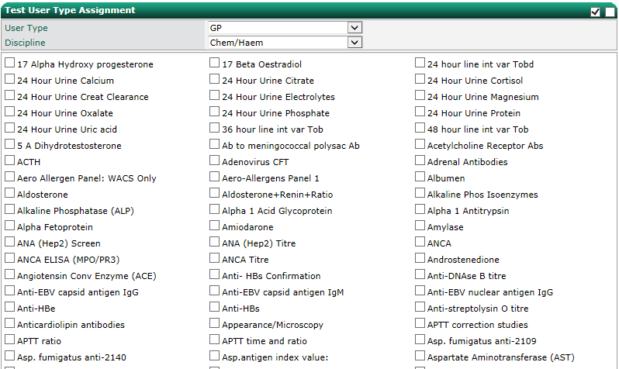
Click Save to save and Cancel to cancel changes. Click Copy to copy the settings from one User Type to another.

Sensitive Tests
Tests within the system can be classified as sensitive. A sensitive test has restrictions on who can view the results of the test and see that it has been requested for a patient. The management of sensitive tests is through the “Sensitive Tests” screen.
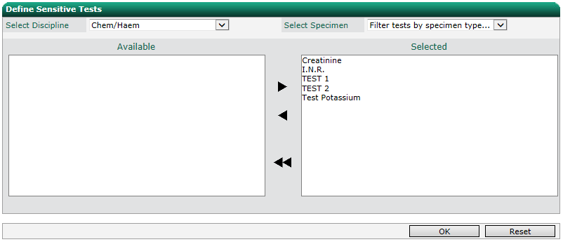
To mark a test as sensitive, select a discipline and specimen type from the drop down lists. Move tests to be marked as sensitive from the Available box to the Selected box by double clicking the test or by using the arrows.

To view tests currently marked as sensitive, expand the “View Current Sensitive Tests” panel.

Note – sensitive tests must be flagged in the Ideagen OCM database prior to marking as sensitive in this way. To add a sensitive test flag, please contact Ideagen Support. Management of users who can see sensitive test results and whether sensitive tests have been requested for a patient is through the user management screen.

Rules
Ideagen OCM allows system administrators to configure various rules to prevent inappropriate or excessive requests and to provide guidance.
Note – Radiology rules can be configured by selecting the “Rules” option from the Radiology Menu.

Test Warnings
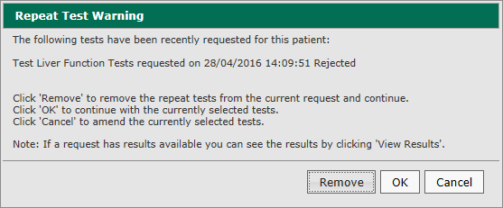
Pop up warning boxes can be displayed on submitting an order when a user has added a test to an order that has been requested within a pre-defined timescale, for example, to prevent excessive requesting.

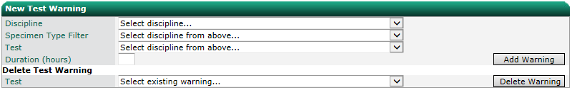
To add a new test warning, select a discipline, specimen type and test. Enter the timescale between tests in hours and click Add Warning. To delete an existing warning, select the test from the drop down list and click Delete Warning.

Linked Tests
Additional tests can be automatically added to an order when a particular test is added.
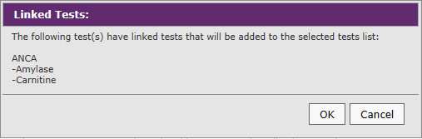
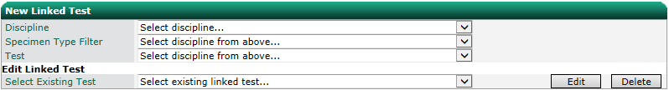
To add a new linked test, select a discipline, specimen type and test. Select one or more tests to link and click OK to save or Cancel to cancel. To modify an existing linked test, select the test from the drop down list and click Edit or click Delete to delete.

Mutually Exclusive Tests
Constraints can be added to prevent two similar tests from being added to the same order.
To add a new mutually exclusive test, select a discipline, specimen type and test. Select one or more tests to link as mutually exclusive and click OK to save or Cancel to cancel. To modify an existing mutually exclusive test, select the test from the drop down list and click Edit or click Delete to delete.
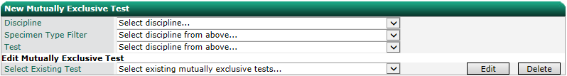

Test Guidance
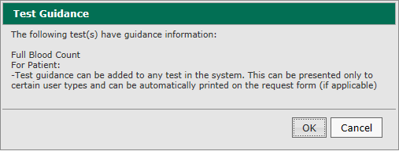
Pop up information boxes can be displayed each time a user adds a test to an order, for example, to provide useful information.

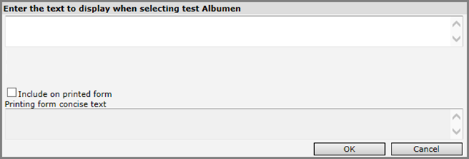
To add guidance for a test, select a discipline, specimen type and test. Enter the text to display. If the guidance is to be printed on the form, tick the box and enter the text you wish to print. Click OK to save or Cancel to cancel.

Note – links to an external site can also be included in the guidance. It should follow the standard HTML anchor tag format for example: <a target='_blank' href='http://bbc.co.uk'>Click Here</a>.
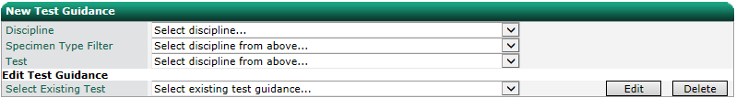
To modify existing guidance, select the test from the drop-down list and click Edit or click Delete to delete.

Test Gender Constraint
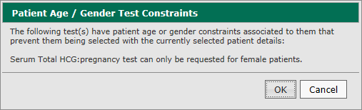
Constraints can be added to prevent a test from being requested for a patient with a particular gender, for example, a pregnancy test for a male patient.

To add a new gender constraint, select a discipline, specimen type and test. Select the gender to which the test applies and click OK to save or Cancel to cancel. To modify an existing gender constraint, select the test from the drop down list and click Edit or click Delete to delete.
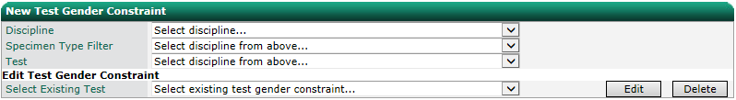

Test Age Constraint
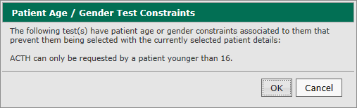
Constraints can be added to prevent a test from being requested for a patient between particular ages, for example, tests not relevant for paediatric patients.

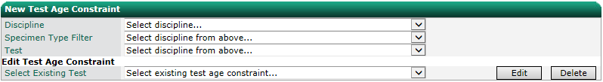
To add a new age constraint, select a discipline, specimen type and test. Enter the age range to which the test applies and click OK to save or Cancel to cancel. To modify an existing age constraint, select the test from the drop-down list and click Edit or click Delete to delete.

Test Clinical Detail
Pop up prompts for clinical details can be displayed when a particular test is added to an order. The user will need to select from the list of configured clinical details before they can continue with the order. The selected clinical detail will be added to the order along with any manually added clinical details.
Note - a ‘Not Applicable’ coded clinical detail can be added to the system. This can be added as a final option in case none of the clinical details presented are appropriate. The code for this clinical detail can be removed from the request message to the lab system.
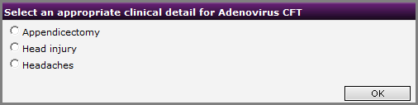
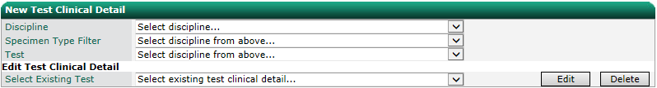
To add a new clinical detail prompt, select a discipline, specimen type and test. Begin typing the clinical details expansion into the text box. It will present a list of matching clinical details. Select one to add to the list. Repeat until all required clinical details are added and click OK to save or Cancel to cancel. To modify an existing age constraint, select the test from the drop-down list and click Edit or click Delete to delete.

Adding a Fasting Clinical Detail
To prompt a user to select between a fasting and non-fasting clinical detail, clinical details records can be added to the system for “Fasting” (configured as “Is Fasting”) and “Non-Fasting” (configured as “Non Fasting”)

By creating a new clinical detail rule against a glucose test, users will be prompted to select whether the test is fasting or non-fasting.

Alternatively, if the clinical detail specified as “Is Non Fasting” in clinical details management is selected, the fasting drop down changes to “No” if not already selected.
Once one “Fasting” prompt has been answered, any other tests selected with the same fasting options will not trigger the prompt again. If the fasting drop down has already been set to “Yes” prior to any fasting prompts been shown, no fasting prompts will be presented to the user (it is assumed that if the user has changed the fasting to “Yes” then it is a fasting request).
If Non Fasting has been selected, the code NF will not be included in the coded clinical details field sent to the LIMS system.

Cross Specimen Requesting
Note – cross specimen requesting is obsolete – do not use.

Test Lists

Personal, Location & Global Order Lists
Order lists allow the quick selection of pre-defined, regularly used tests. Ideagen OCM supports the configuration of the types of order lists:
- Global – configured by a system administrator, available to all system users
- Location – configured by a system administrator, available to all users within an individual location
- Personal – configured by an individual user with appropriate permissions
Order lists are all configured in the same way. To add a new order list, from the configuration screen, click Test Lists and then My Order Lists, Location Order Lists, or Global Order Lists.
Order lists can be separated into sections, so you can choose whether to add all tests in the order list, or only tests within a particular section.
Enter a name for the list and update the name for the first section.
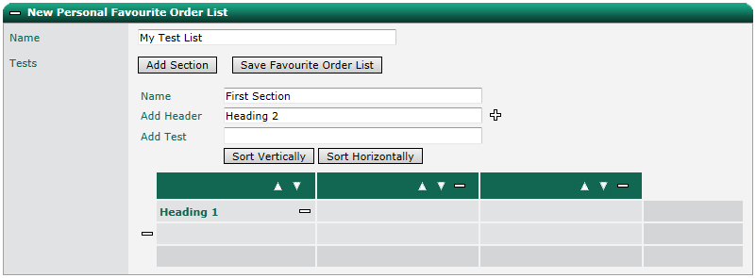
To add a header label, enter text into the header field and click the + button.

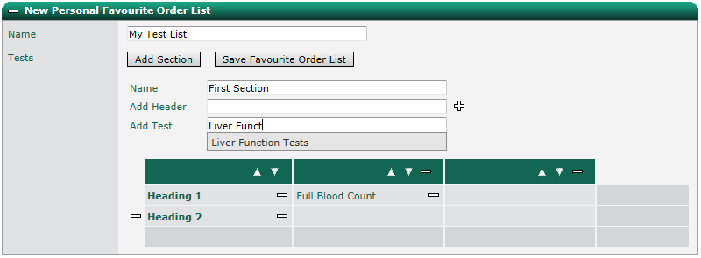
To add a test to a section, begin typing the name of the test in the “Add Test” box. It will present a list of matching tests. Select one to add to the list.

Once added to a section, tests and headers can be moved by dragging and dropping.
To create additional columns, drag a header or test into the right-hand column (the one without a header). To remove a column or row, click the – button.
Note – when deleting a column or row, all tests/headers in the column/row will also be removed.
To add a new section, click the Add Section button and update the section name. To remove a section, click the Delete Section button.
Note – it is not possible to delete the first section as an order list must contain at least one section.
To modify how tests and headers are displayed within a section, click Sort Horizontally / Sort Vertically or use the arrow buttons.
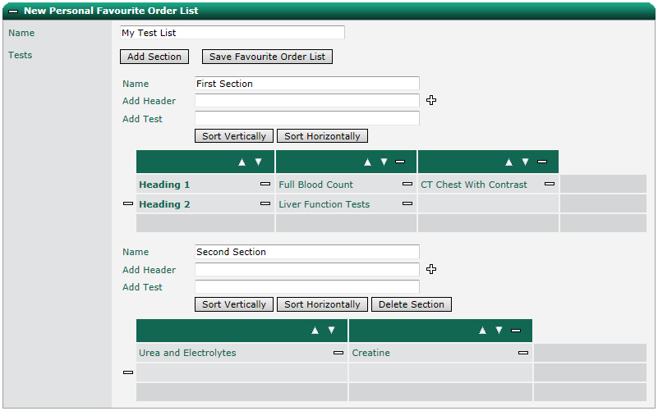
Click Save Favourite Order List to save.

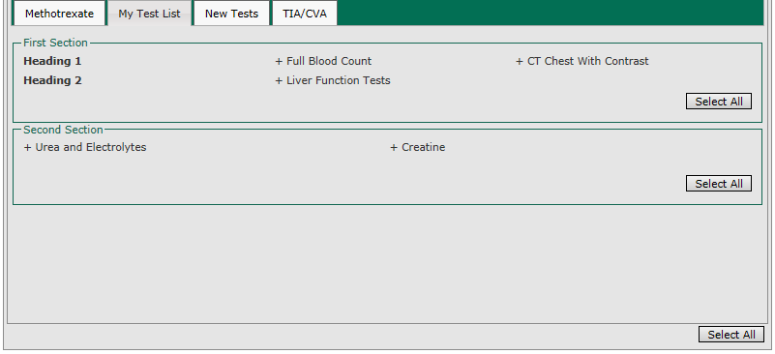
The above configuration will appear like this on the ordering screen:

To modify an order list, expand the “Edit Personal Favourite Order List” panel on the “My Order Lists” screen. Select a list to modify and click Save Favourite Order List to save or Delete Favourite Order List to delete.
Note – tests added to lists can belong to multiple diagnostic departments.

Investigations
Investigation based order sets work in a similar way to favourite tests. The only difference is that users must first select a presenting complaint/diagnosis from a drop-down list. One or more order sets with then be displayed below the drop-down.
To add a new Investigation list, from the configuration screen, click Test Lists and then Investigations.
Enter a name for the investigation, this would normally be a description of the presenting complaint or diagnosis to allow a user to select it from the investigations drop down list.
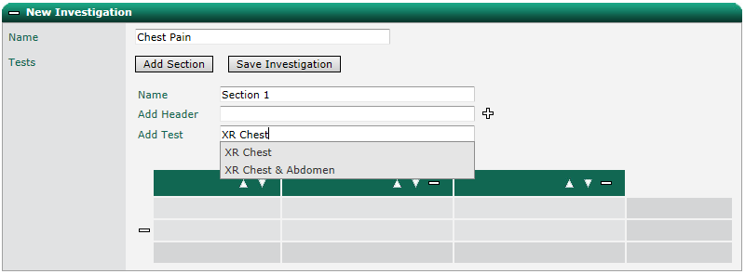
Continue to create the list in the same way as described above.

To modify an investigation list, expand the “Edit Investigation” panel on the “Investigations” screen. Select a list to modify and click Save Investigation to save or Delete Investigation to delete.
Note – tests added to investigation lists can belong to multiple diagnostic departments.

Personal, Location & Global Favourites
Note – favourite tests can only currently be selected when modifying a request.
Favourite tests allow the quick selection of pre-defined, regularly used tests. Ideagen OCM supports the configuration of the types of favourite tests:
- Global – configured by a system administrator, available to all system users
- Location – configured by a system administrator, available to all users within an individual location
- Personal – configured by an individual user with appropriate permissions
Test lists are all configured in the same way. To add a new favourite test list, from the configuration screen, click Test Lists and then My Favourites, Location Favourites, or Global Favourites.
To add a new favourite tests list, select a discipline. Select a specimen type to filter the list further.
Note – if adding a location based favourites list, a location will need to be selected by typing the name of the location into the box and clicking Select.
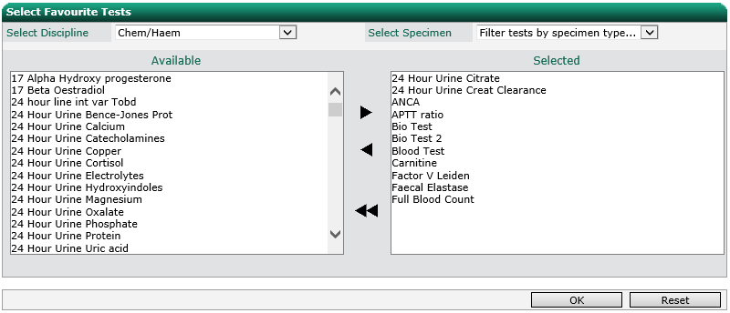
Select the favourite tests for the selected discipline by double clicking or selecting and moving with the arrow buttons. Click OK to save or Reset to reset the lists.

To view all favourite tests, expand the “Show Current Favourite Tests” panel.
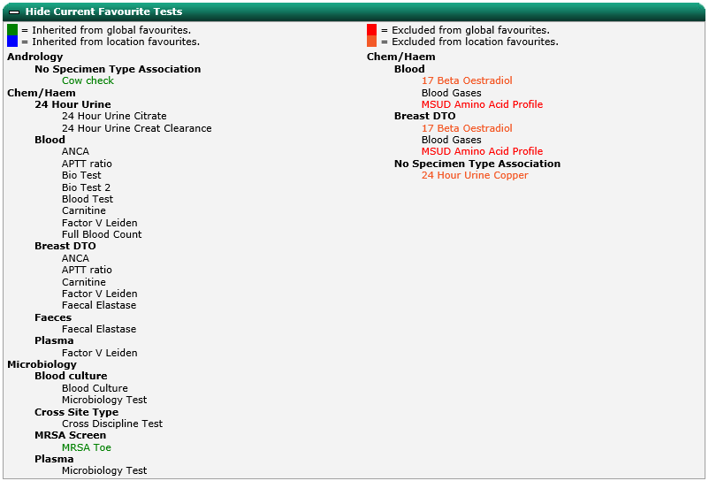
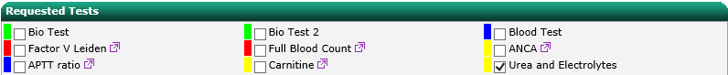
Note – my favourites are currently only available from the individual request screens that are displayed after the original order has been submitted, for example, when editing the original request.

Request Configuration

Questions
In Ideagen OCM, the tests selected determine which details need to be obtained as part of the order. Questions can be based on the discipline/diagnostic department, specimen type, specimen site, modalities etc of the tests added to the order.

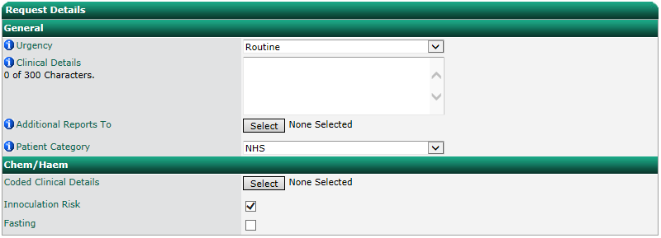
As a user selects tests, the request details section of the order screen dynamically updates to reflect the questions that need to be answered.

Request questions can be configured to be either discrete or non-discrete. Questions that appear in the General tab are questions that have been configured to be non- discrete which means they will only appear once regardless of how many times the same non-discrete question is associated with different disciplines, specimen types and tests etc.
Questions that have been placed under the specific discipline, specimen type, or test etc. are configured to be discrete questions, which means the question will appear multiple times and require a different answer for each association the question has with a discipline, specimen type, or test etc.

Creating Test Questions
Ideagen OCM supports various questions types. Each question can include an age and/or gender constraint to cause them to display only for patients of a particular age and or gender.
Questions can be set as mandatory, forcing the user to answer before allowing the order to be submitted. A validation dialogue will appear highlighting any questions that need to be answered.
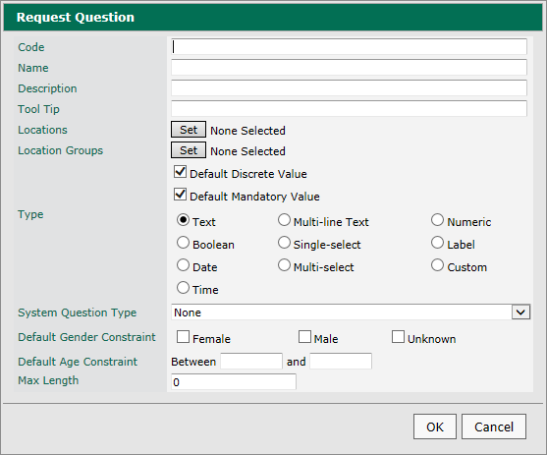
To create a new test question, click the Add button below the questions list. Enter a code, name (as displayed in the question list) and description for the question (question text).

Enter any information useful to users in the “Tool Tip” field. The tooltip will display when the user hovers over the question text on the order screen.
Click Set next to “Locations” to select the default locations for which this question will be displayed when applied.
Click Set next to “Location Groups” to select the default groups of locations for which this question will be displayed when applied.
Tick “Default Discrete Value” if you want the question to appear separately for each test/examination it is associated with rather than combined to appear only once in on the order screen.
Tick “Default Mandatory Value” if you want the question to be mandatory by default.
Select the type of question.
If the response to the question is to be printed on the request form it must be mapped to one of the system questions by selecting the appropriate option from the drop down list.
Enter any default age or gender constraints.
Note – default locations and groups, discrete and mandatory settings and age/gender constraints can be overridden when applying the question to a specific discipline, modality, specimen type or site.
Depending on the type of question selected, there will be different additional options displayed.
- Text
  - Maximum response length
- Multiline Text
  - Maximum response length
- Single Select
  - Available responses
  - Type – drop down or radio buttons
- Multiple Select
  - Available responses
  - Type – drop down or radio buttons
- Boolean
  - “True” and “False” responses visible to users
  - Type – check boxes or radio buttons
- Numeric
  - Minimum value
  - Maximum value
  - Decimal places
  - Units
- Date
  - Option to default to current date
  - Option to include time
  - Option to restrict to future dates only
- Time
  - Option to default to current time
- Label
  - Label text
  - Option to display in bold
- Custom Type Questions – questions that use special controls for answers (for example, the coded clinical details question provides a select button and pop up that allows the selection of clinical details)
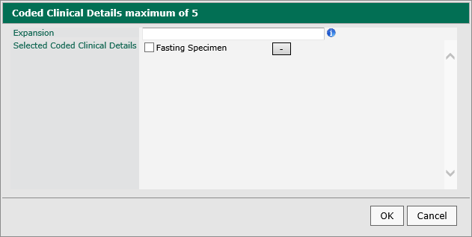

Click OK to add the question or Cancel to cancel.
To modify a test question, select the question from the list and click Edit. Click Delete to remove at test question.

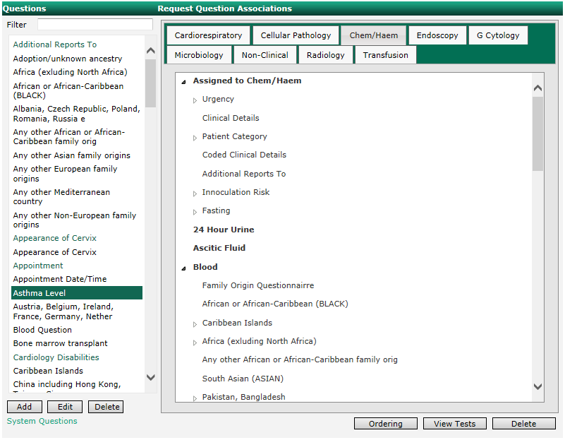
Applying Test Questions
To apply a test question, select it from the list and drag to the appropriate discipline (for example, under “Assigned to Chem/Haem”) or specimen type (for example, under “Blood”) on the right-hand side of the screen.

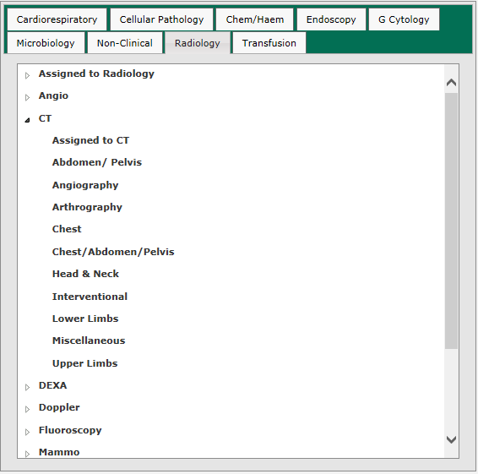
For Radiology, tests can be applied to the whole of radiology (for example, under “Radiology”), to a modality (for example, under “CT”) or to an exam site (for example, under “CT/Chest”)

When a question has been added, you will be prompted to configure the instance settings for the question.
By default, the question will be applied to the whole of the discipline, sample type/modality or site that the question was added to. To restrict the question to one or more tests/examinations, click “Assign to specific tests” and select the relevant tests/examinations from the list.
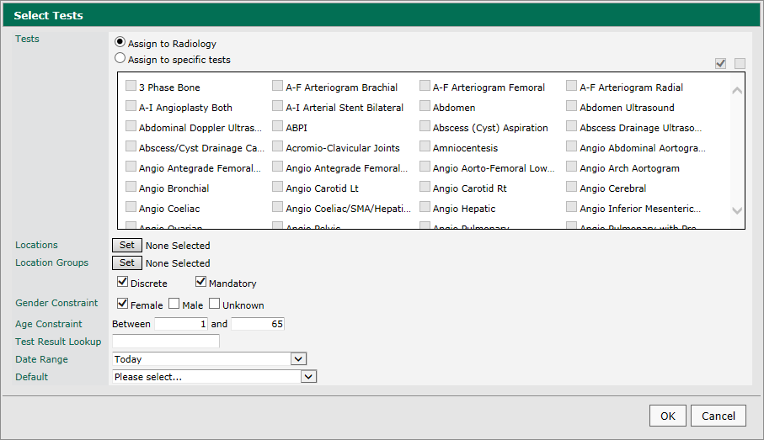

Click Set next to “Locations” to override the default locations set when the question was added to the system.
Click Set next to “Location Groups” to override the default groups of locations set when the question was added to the system.
Tick or untick “Default Discrete Value” to override the default setting set when the question was added to the system.
Tick or untick “Default Mandatory Value” to the override the default setting set when the question was added to the system.
Enter any default age or gender constraints to override the default settings set when the question was added to the system.
For selection questions, you can set a default response.
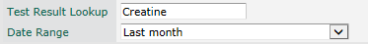
For numeric results, it is possible to automatically populate the response with the result of a previous test, within a configured number of days.

Click OK to save or Cancel to cancel.
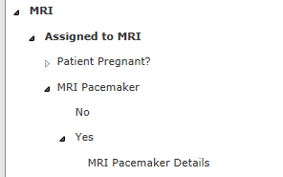
Where questions have predefined responses, for example, Boolean, single or multi select, it is possible to add follow up questions based on the response by dragging and dropping the question over the response that should trigger the follow up question to be displayed.

To modify the order of questions, click Ordering. Questions can be dragged and dropped into their required positions. Click Reset Order to reset or Cancel to cancel changes.
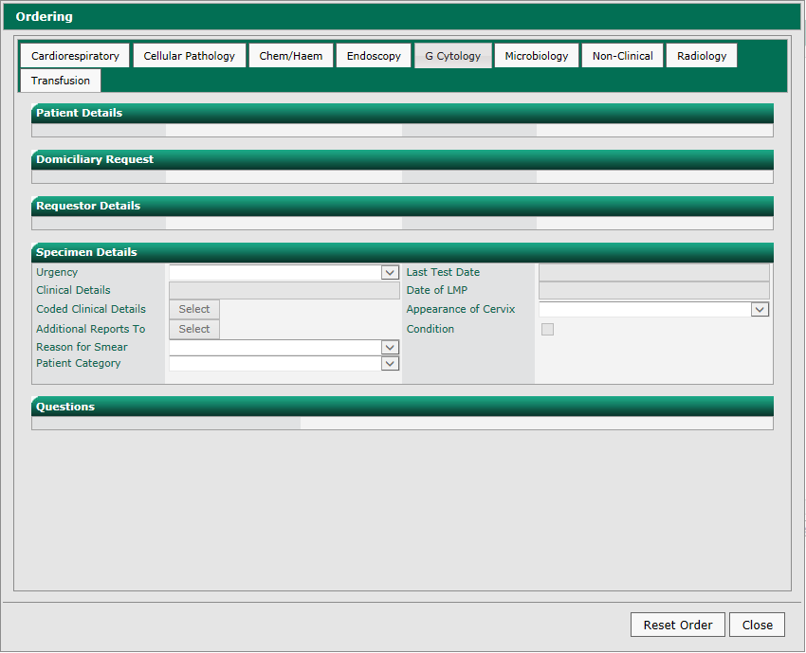

Process Actions
Process actions are a highly flexible way of defining the workflows for a disciplines and diagnostic departments. Workflows can include user prompts and actions, questions, printing forms or labels, request vetting, updating statuses, transmitting request messages, and adding to queues.
To define a workflow, first add one or more action groups by clicking Add Action Group.
Enter a group name and display name.
Click “Send requests to clinical system on completion” to display a screen on completion of this action group to allow a GP practice system to collect XML based request details from Ideagen OCM to enter onto the GP record.
Tick “Auto Process” to automatically display the action or tick “Execute Individually” to display a button to allow users to select which action to carry out.
Click Set next to “Request Statuses” to configure the status that this action group will be available.
Click Set next to “Locations” to configure the locations for which this action group will be available.
Click Set next to “Location Groups” to configure the groups of locations for which this action group will be available.
Click Set next to “User Types” to configure the user types for which this action group will be available.
Click Set next to “Request Split Options” to configure requests to be split into sub requests.
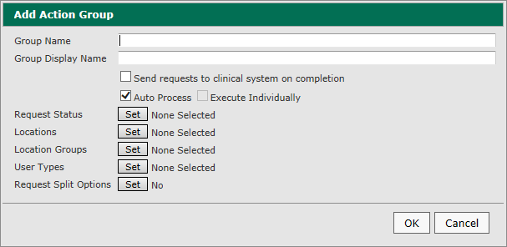
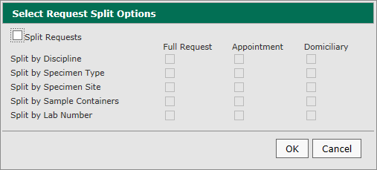
Tick “Split Requests” to enable splitting and select how to split (by discipline, specimen type, specimen site and/or sample containers)

Note – Appointment, Domiciliary and Split by Lab Number are obsolete – do not use.
Add one or more actions from the list to the action group. Available actions:
- Ask Request Question – prompt the user to answer a question (defined in “Test Questions”)
- Assign Lab Number – assign a lab number from the range defined in “Specimen Numbers”
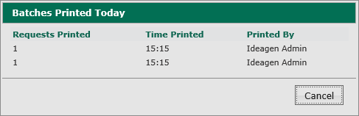
- Audit Request Print - when printed from the Phlebotomy, Radiology or Cardiology Printing screen, this option causes details to captured for display when the user clicks the Audit button on those screens.

- Check Request Question Answer – check the answer to a system question from the submitted order
- Confirm - display a configurable confirmation box with configurable text. If multiple requests are being processed, the request numbers are listed so the user can tick which requests they are providing the confirmation for.
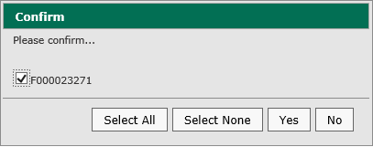
- Lock Request – sets a stage in the workflow where the original request can no longer be modified.
- Mark as Printed – sets the printed flag to true.
- Mark for Home – sets the home flag to true.
- Print Form – prints a form based on the request discipline and type.
Note – form layouts are currently hard coded and can only be updated by Ideagen Support.
- Repeat Request – displays number of repeating requests and interval selection fields to automatically generate the correct number of future request at the selected frequency.
Note - to use the repeating test functionality, the action group must have the “Earliest Collection Date” system question added.
- Set Request Status – updates the request status. The status is also used to trigger additional action groups.
Select the status and click OK.
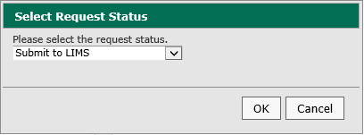
- Show and Print Sample Labels - prints labels based on the request discipline and type.
Note – label layouts are currently hard coded and can only be updated by Ideagen Support.
- Test Guidance - displays test guidance added for a particular test at the configured stage in the workflow.

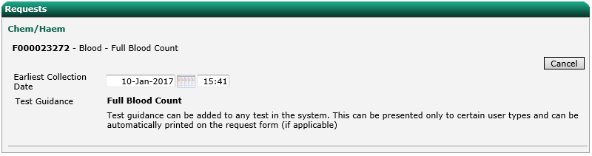
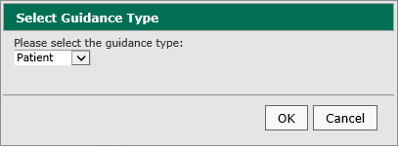
Select whether the guidance is for the Patient or Requestor and click OK.

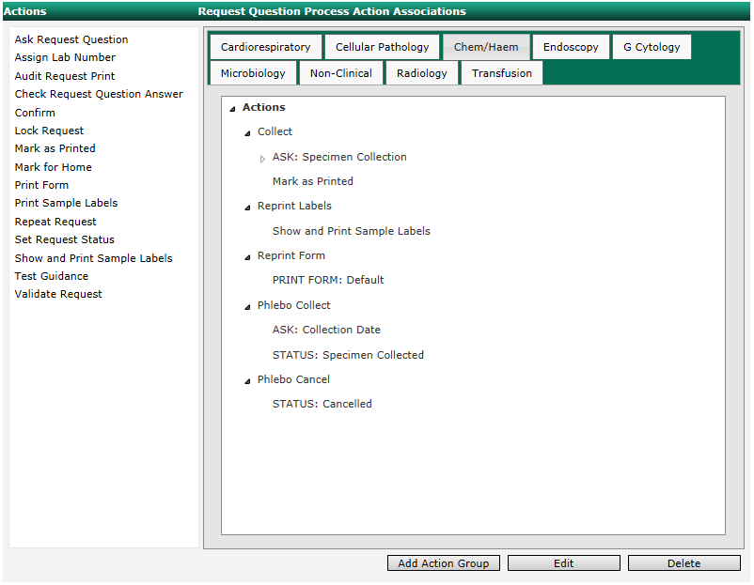
- Validate Request – displays a dialog box for a user to enter their username and password. This is used to ensure only appropriate users (doctors) submit radiology requests that may have been completed by a user not authorised to submit according to regulations.

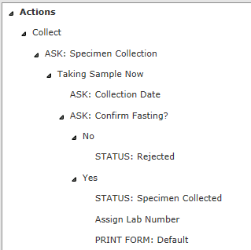
Where questions are added using the “Ask Request Question” option that have predefined responses, for example, Boolean, single or multi select, it is possible to add follow up questions based on the response by dragging and dropping the question over the response that should trigger the follow up question to be displayed.

Select an action group and click Edit to edit or Delete to delete.

Request Configuration Import/Export
To import request questions and process actions, click Browse, select the appropriate XML file, and click Import.
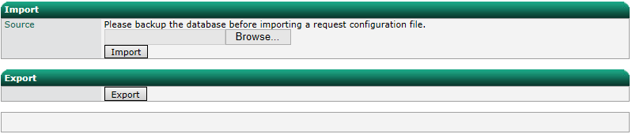
To export request questions and process actions, click Export and select a location to save the XML file.

Print Settings
When a user generates a request within Ideagen OCM, it only exists within the system as an electronic request. It is possible to configure requests to be printed on a physical request form or labels to be attached to the specimen.
Physical request forms may include one or more pre-cut labels to attach to sample tubes/containers. This type of stationary is loaded into the printer in the same way as normal paper. Request details are printed on the form, and barcodes printed on the peel off labels.
Ideagen OCM provides two options for printing forms:
- Normal Internet Explorer printing
- Advanced printing
Advance printing is recommended as it gives better control over the printout position and involves less steps to print a form.
An alternative to a full request form is the appointment form. A particular specimen type can be configured to print an appointment form rather than the full request form. The appointment form is given to the patient who takes it to a sample taker. The sample taker collects the sample and prints labels via a label printer for the sample tubes/containers.

Internet Explorer Printing
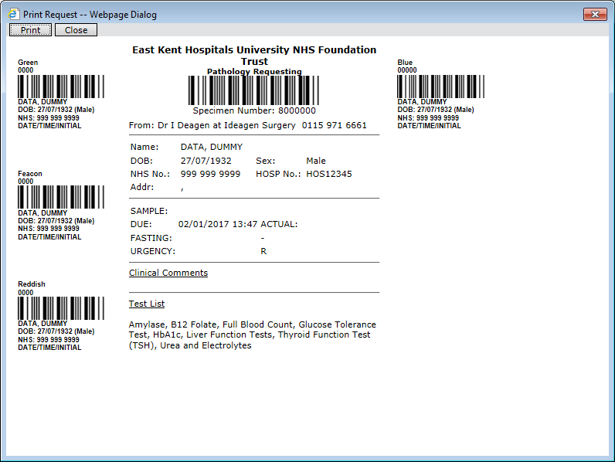
When a user submits a new request, a new window will open with the request details formatted for printing.

Users click Print to open the Internet Explorer print dialog.
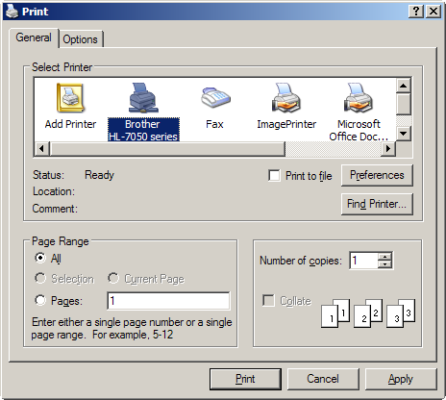

Users must then click Preferences and change the settings to A5 and landscape. Then click OK and Print.
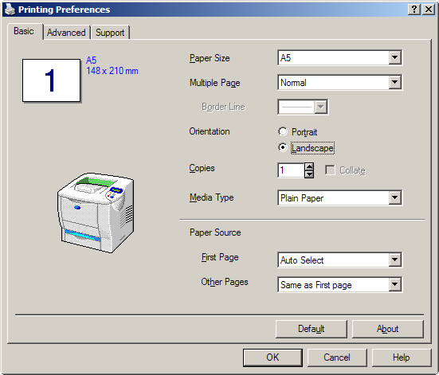

The request will be printed to the selected printer. Internet Explorer does not remember these settings so they must be repeated every time a request is printed.

Advanced Printing
Advanced printing is configured per location. By default, locations are not setup to use advanced printing.

Location Print Settings
To configure advanced printing for a location, begin typing the name in the “Location Name” field. As you type, valid location names will appear in a drop down below the field. Select the required location form the drop down and click Select.
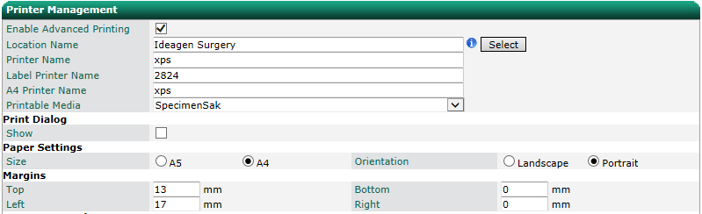
To enable or disable advanced printing for the selected location, check or uncheck “Enable Advanced Printing”. When enabled, all fields will become editable.

Fields:
- Printer Name - If a valid printer name is not specified in this field the requests will print to the default printer on the computer the user is using to access Ideagen OCM. If all requests are to be printed to a single printer within the location, then a valid printer name needs to be entered into this field. The printer name should include the computer name and printer name in the format “\\Computername\Printername”.
- Label Printer Name – This field specifies the name of the label printer that any labels will be printed out on. You do not need to enter the full printer name, for example, if Windows displays the printer as “Zebra LP 2824”, “LP 2824” can be entered and the system will still find the printer.
- A4 Printer Name – If a valid printer name is not specified in this field, the requests will print to the default printer on the computer the user is using to access Ideagen OCM. Some requests are printed to A4 paper i.e. Radiology and cardiology. The printer specified in the Printer Name field will generally be loaded with A5 request forms. The A4 Printer Name is used so these requests can be sent to a printer loaded with A4 paper. The printer name should include the computer name and printer name in the format “\\Computername\Printername”.
- Print Dialog/Show – Check this box if you would still like to see the Internet Explorer print dialog. This is not recommended as the settings (i.e. A5 and landscape) are not always passed through and will still need to be manually set.
- Paper Settings/Size – Select which paper size for printed requests.
- Paper Settings/Orientation – Select which paper orientation for printed requests.
- Margins – Adjusting the margins allows the fine adjustment of the printing position. These fields can be adjusted to make sure the barcodes correctly line up within the labels on the stationary.
Click Update to save the changes to the system.
When the user clicks Save and Print within the request form a new window will open with the request details formatted for printing in the same way as normal Internet Explorer printing. However, with advanced printing enabled, the form will be printed to the computers default printer or specified printer with all the settings specified for the location. The user does not have to go through the process of selecting the settings every time they print a request form.

Specimen Number Assignment

The specimen number prefix and associated number range for each location is configured via the Specimen Number Assignment section.
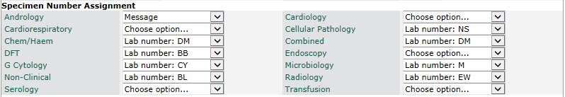
In the above example, a Blood Science request will be assigned a number from the DM range. The actual prefix added to the specimen number when submitted to the LIMS system varies by implementation.

Appointment Cards

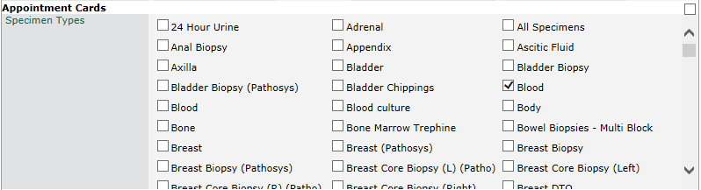
An appointment form can be printed for particular requests. To specify that appointment forms are printed for a particular specimen type, the type needs to be selected in the Appointment Cards section.

In the above example, an appointment form will be printed when requesting a Blood specimen request.

Request Form Content
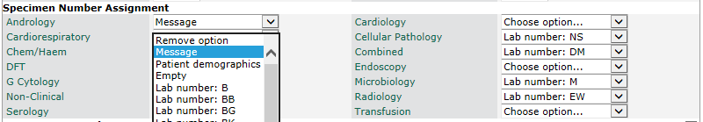
The Message section of the Print Management screen allows configuration of the left portion of the printed request form if a message has been specified for that discipline. The left content can be configured per location and discipline using the Specimen Number Assignment section. The available options are a message, patient demographics, empty or a specimen number.

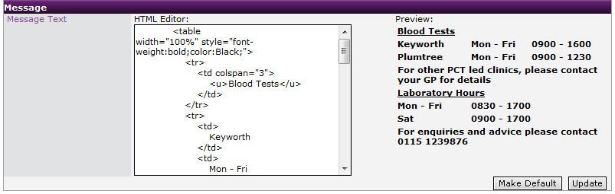
To assign the currently displayed settings to be the default for all unconfigured locations click Make Default. To make the changes to the selected location only click Update.

Message
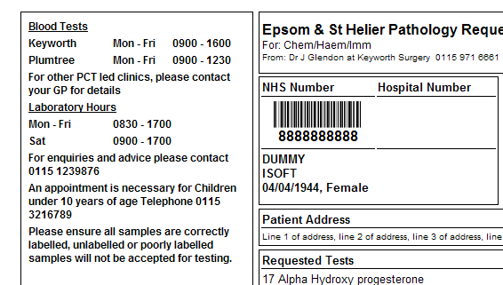
When a user at a location saves a request for a discipline configured as “Message” it will be assigned a holding specimen number. When the user prints the request the left content will display the message entered in the print management screen for that location. To edit the message, enter the text in the HTML Editor. The preview will show how it will appear on the form. A valid specimen number will need to be added to the request before it can be submitted.

Patient Demographics
When a user at a location saves a request for a discipline configured as “Patient Demographics” it will be assigned a holding specimen number. When the user prints the request the left content will display the patient details aligned to the labels on the request form. A valid specimen number will need to be added to the request before it can be submitted.
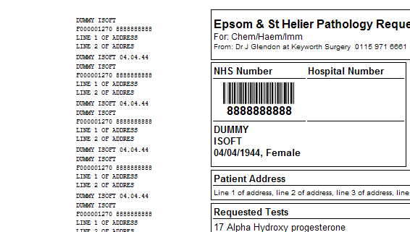

Empty
When a user at a location saves a request for a discipline configured as “Empty” it will be assigned a holding specimen number. When the user prints the request the left content will be empty. A valid specimen number will need to be added to the request before it can be submitted.
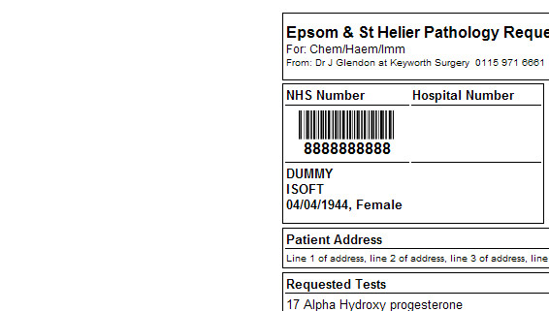

Specimen Number
When a user at a location saves a request for a discipline configured with a “Specimen number” it will be assigned the next valid specimen number from the range. When the user prints the request the left content will display the patient details with a specimen number barcode aligned to the labels on the request form. The request can be submitted without adding another specimen number.
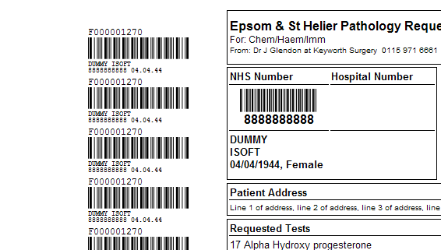

Machine Print Settings
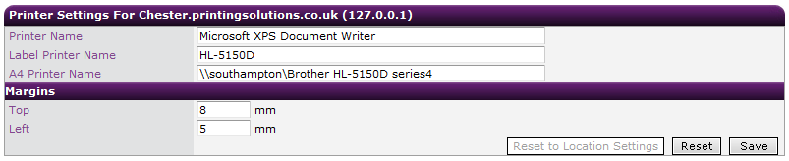
Occasionally, the location print settings set for a location do not suit all the computers at particular location. The Local Machine Printer Management page allows a user to make minor changes to the print settings for an individual computer. To access the screen, select Configuration from the Main Menu, and select Print Settings from the Action menu, then select the By Machine sub-menu option.

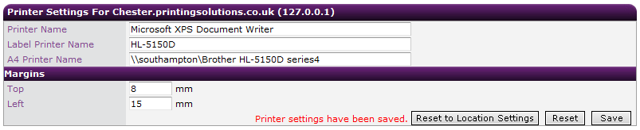
By default, the screen will be populated with the location settings. The ‘Printer Name’ field can be changed so the request/appointment forms can be printed to a different printer. The ‘Label Printer Name’ field can be changed so the labels can be printed to a different label printer. The A4 Printer can be changed so requests printed to A4 paper can be sent to another printer. The two margin fields change the positioning of the printed request form. These allow for fine tuning the position of the printout so the request lines up correctly with the pre-cut labels. Changing ‘Top’ from 5 to 7 will move the printout 2mm down. Changing ‘Left’ from 4 to 6 will move the printout 2mm to the right. To save the settings click Save.

Changes are computer specific and are not related to a particular user. Any user who uses the machine from now on will inherit these settings.
If you make changes, but do not wish to save them click Reset. No changes will be saved.
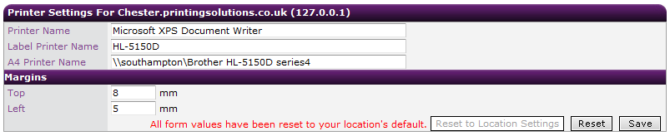
To revert a computer back to using the location settings click Reset to Location Settings. This will remove any custom settings for the machine.

Permissions

Access Permissions
Access to the various screens can be configured by user type within the “Access Permissions” screen.
When entering the “Access Permissions” page the drop down list defaults to super admins. By default, super admins can see all screens within the system. To view the permissions for another user type, select the type from the drop down. The screen will update to show the permissions for the selected user type.
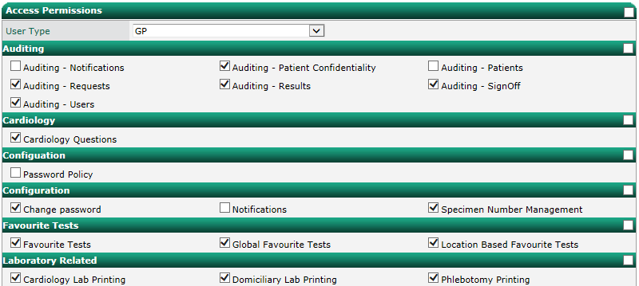
To amend permissions, check/uncheck the check box next to the screen name to enable/disable access to that screen.
The check boxes to the right of each section can be used to select/deselect all the screens within that section. The check box at the very top right can be used to select/deselect all the check boxes on the screen. When finished, click Save to save the changes to the system or click Cancel to cancel changes.

Email
Note – obsolete – do not use.

Notifications
Ideagen OCM can be configured to send email notifications to requestors at set trigger points.
To create a new notification, you must first configure an email template. To create a new template, enter a code and description. Select a discipline and whether the email should be flagged as urgent. Enter the email subject.
For the email body, the buttons can be used along with free text to automatically populate information such as patient demographic or result information. To automatically insert a link to direct the reader to the result within Ideagen OCM, click the Report Link button and enter the text that should be displayed.
Click Add New Email Template to save.
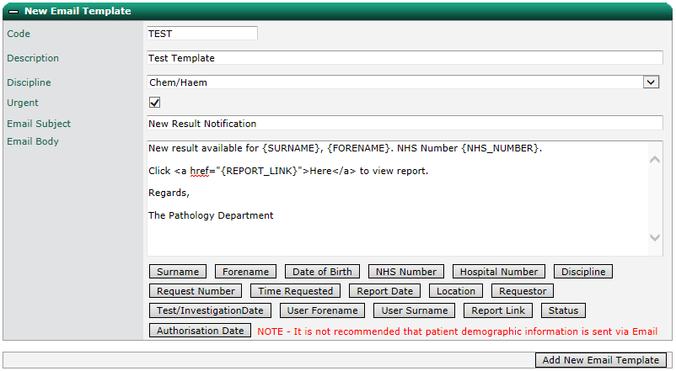
To modify an email template, open the “Edit Email Template” panel, select the template from the drop down list. Update the information and click Save Changes to save or Delete Template to delete the email template.
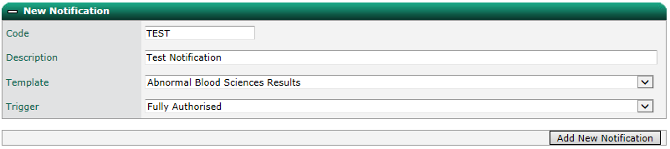
To create a new notification, enter a code and description, then select a pre-defined template. Select the trigger that should initiate the transmission of the selected email and click Add New Notification.

Note – when selecting “Not Viewed” or “Not Signed Off”, you need to enter a delay so the system allows enough time before reminding a requestor that results haven’t been viewed/signed off.
To modify a notification, open the “Edit Notification” panel, select the template from the drop down list. Update the information and click Save Changes to save or Delete Template to delete the email template.

Patient Management

My Patients
Note – not required by system administrators.

Patient Merge
The Patient Merge screen allows the merging of duplicate patients. If Ideagen OCM contains multiple patient records for the same physical patient, the records can be merged together to leave a single record.
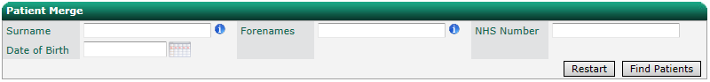
Search for the patient records to be merged using the search criteria. Wildcard searching can be used with the ‘*’ character.

Hovering over a surname will show the address details for the patient.
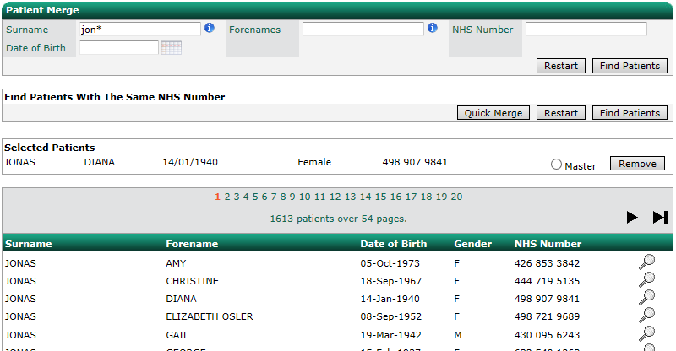
To begin the merge process, select the patient records that need to be merged by clicking on the patient row. When clicked, the patient will show in the selected patient section.

It is possible to perform multiple searches (including finding patients with the same NHS Number) without losing the selected patients.
Once two or more patients are selected, the merge button is displayed. To remove a patient record, click the corresponding Remove button.
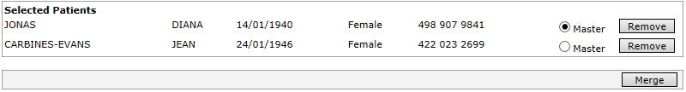
Two or more patients can be merged at the same time. Select all the records that need to be merged and choose the master record. The master record is the patient details that will be retained. All other patients will be removed from the system once all their requests and results have been associated with the master record.

Click Merge to perform the patient merge. A confirmation message will be displayed when patients have been successfully merged.

Quick Merge
Quick patient merge can be performed by clicking the Quick Merge button under the “Find Patients With The Same NHS Number” panel. Quick Merge works on the same set of patients returned by clicking Find Patients under the “Find Patients With The Same NHS Number’ section. When clicked the first set of patients with the same NHS number are presented to the user.
Click Merge to merge the patients. The master patient will default to the newest entry in the system. Click Skip to skip the merge, but only for the current users’ session or until they click Restart. When either Skip or Merge are clicked, the next set of patients with the same NHS number are presented to the user.
At the end of a batch of quick merges, any skipped merges can be seen by clicking Find Patients under the ‘Find Patients With The Same NHS Number’ section.
Skipped merges will be at the top of the results. Clicking the magnifying glass at the end of the row will perform a search for that NHS number to allow you to view any requests and results associated with a patient record to better determine which patient records need to be merged.
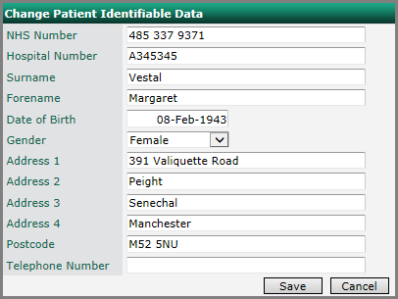
To change patient any of the patient details within a record, click Change PID.

Patient Data Transfer
If a request or report is assigned to the wrong patient, Patient Data Transfer screen can be used to rectify the problem.
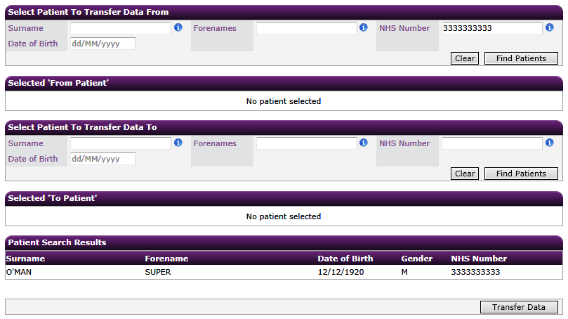
Enter search criteria for the patient from which the data will be transferred and click Find Patients. Matching patients will be displayed in the Patient Search Results section.

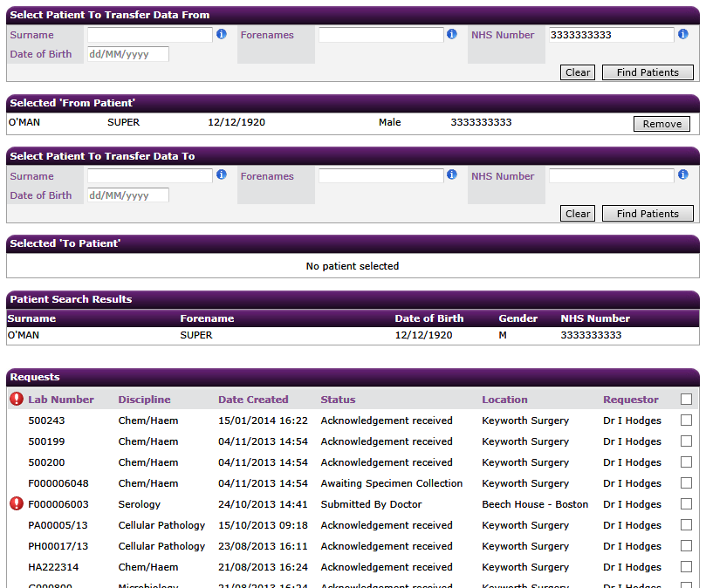
Click the required patient to load them into the “Selected ‘From Patient’” section. The patient’s requests and results will be loaded.

Enter search criteria for the patient to which the data will be transferred and click Find Patients.
Click the required patient to load them into the “Selected ‘To Patient’” section. The patient’s requests and results will be loaded.
Select the requests and/or results that need to be moved to the “To Patient”.

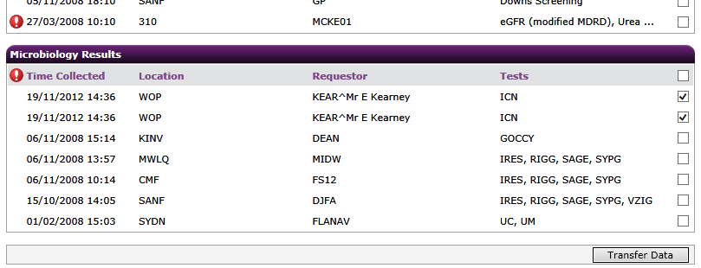

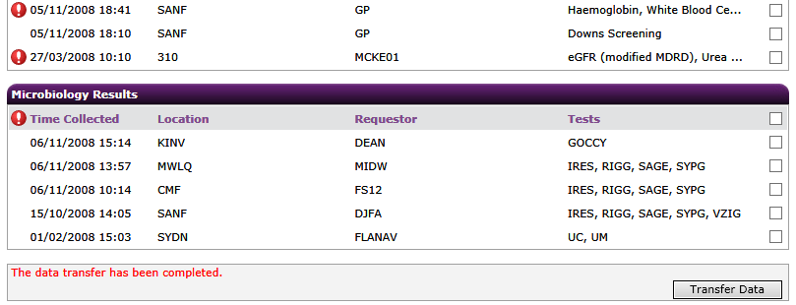
Click Transfer Data and click Yes at the prompt to continue or No to go back.

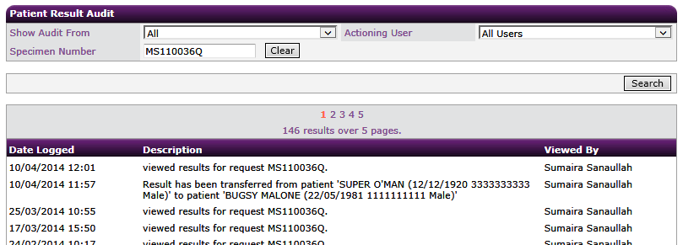
Each moved item will have an audit entry added to indicate that it was initially assigned to a different patient.

Change Password
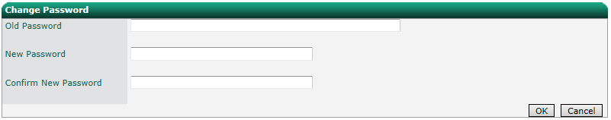
To change your password, select Configuration from the Main Menu, then Change Password from the Action menu.

Enter your old password and enter a new password in the two new password boxes. Click OK to save.
Note – you will be warned if your password does not meet the configured password policy.

Password Policy
Every user must have a password that meets the configured password policy. The complexity of the password policy can be amended via the Password Policy screen.
The following options can be configured:
- Total password length
- Number of numerical characters.
- Number of symbol characters (non-alphanumeric).
- Whether the password must be mixed case
- Number of upper case characters
- Number of lower case characters
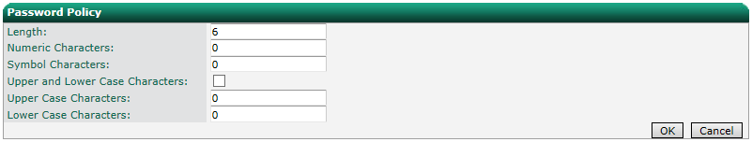
Once the desired complexity has been set, click OK to save. The policy will be applied when a user next needs to change their password.

Specimen Numbers
Ideagen OCM can be configured to automatically assign specimen numbers to requests when they are saved. The specimen number assigned to the request depends on which discipline the request is for and which location it originates from.
Within the ‘Specimen Numbers’ screen you can add, edit and delete specimen numbers. Changing existing specimen numbers can have adverse effects on the system and should only be changed with caution. To add a new specimen number, enter a prefix, a lower limit, and an upper limit.

Click Add to add the specimen number to the system or click Cancel to cancel. To make the new specimen number available for use it needs to be associated to a location and discipline. This step is performed in the “Print Settings” screen.

Edit an existing location and set one of the disciplines to use the new specimen number. Click Update to save the changes to the system. In this example, when the requestor saves a request for Cellular Pathology the specimen number will be prefixed with ‘NS’ and start counting from 1000. With each new request the counter is incremented up to the upper limit at which point it restarts from the lower limit.
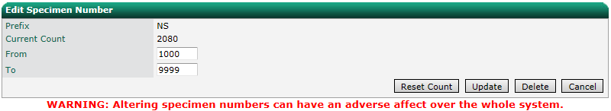
To edit a specimen number, select it from the drop down list. You can then change the upper and lower limits of the specimen number. Click Update to save the changes. The specimen number will be reset and the counter will start from the new lower limit. To reset the specimen number to the lower limit without changing the specimen numbers properties click Reset Count. Click Cancel to cancel, or click Delete to remove the specimen number.

Radiology

Location Exams
Location Exams allows you to restrict the use of radiology examinations from particular locations. To restrict access, select a location from the drop down list. Select the examinations to be available for the location and click Save to save or Cancel to cancel changes.
Note - by default, all examinations are unchecked for a user type. This means that the user will have access to all examinations, the same effect as ticking all examinations.
Ticking one or more examination will mean users of that user type will only have access to request the selected examinations.
Click the buttons at the top right of the screen to select and deselect all tests for a modality.
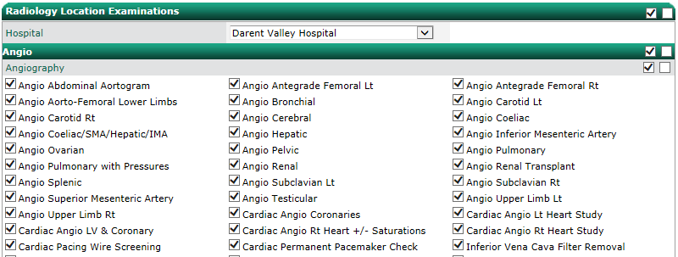

Exam Permissions
The availability of radiology examinations to users of a particular user type can be managed via Exam Permissions screen.
Select a user type from the drop down list.
Note - by default, all examinations are unchecked for a user type. This means that the user will have access to all examinations, the same effect as ticking all examinations.
Ticking one or more examination will mean users of that user type will only have access to request the selected examinations.
“Selectable” means users can select the examination. “Authorised” means that the user can request an examination, but it requires a user with authorise access to submit the request for processing for example, where only a doctor can submit a request for an MRI, not a nurse.
Click the buttons at the top right of the screen to select and deselect all tests for a modality.
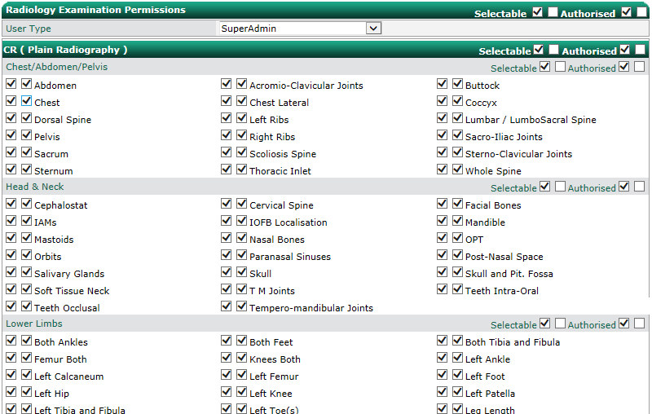
Click Save to save and Cancel to cancel changes. Click Copy to copy the settings from one User Type to another.

Investigations Management
The Investigations Management screen allows you to add, modify and delete Radiology investigations, modalities (exam types) and body areas (exam locations).

Adding an Investigation
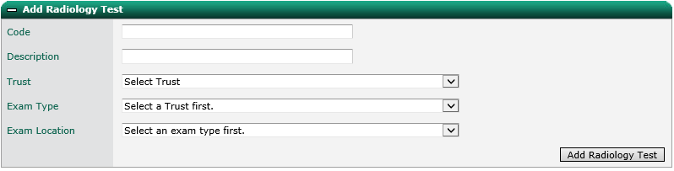
To add a new investigation, enter a code and description.

Select the Trust and select the associated modality from the Exam Type drop down list.
Select an area of the body from the Exam Location drop down list that the examination relates to.
Click Add Radiology Test to add it to the system.

Modifying an Investigation
To modify an investigation, enter the code and click Select. You can then modify all the settings for the investigation. Click Edit Radiology Test to save changes or Delete Radiology Test to remove the investigation from the system.

Adding an Exam Location (Modality)
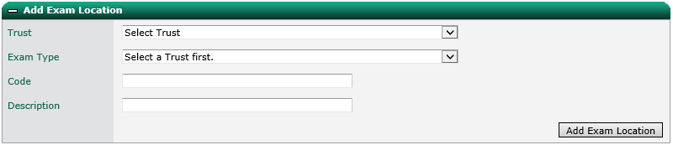
To add a new exam location, select a Trust and exam type. Enter a code and description and click Add Exam Location.

Modifying an Exam Location (Modality)
To modify an exam location, select a Trust, Exam Type and Exam Location. You can then modify all the settings for the exam location. Click Edit Exam Location to save changes or Delete Exam Location to remove the exam location from the system.

Adding an Exam Type
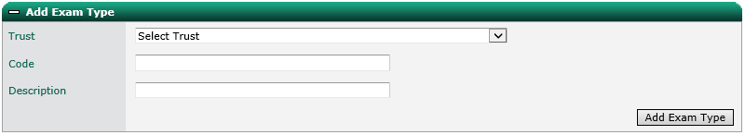
To add a new exam type, select a Trust, enter a code and description, and click Add Exam Type.

Modifying an Exam Type
To modify an exam type, select a Trust and Exam Type. You can then modify all the settings for the exam type. Click Edit Exam Type to save changes or Delete Exam Type to remove the exam type from the system.

Radiology Rules
Ideagen OCM allows system administrators to configure various rules to prevent inappropriate or excessive requests and to provide guidance.

Modality Warnings
Pop up warning boxes can be displayed on submitting an order when a user has added a Radiology investigation to an order with the same examination type (Modality) of an investigation that has been requested within a pre-defined timescale, for example, to prevent excessive requesting.
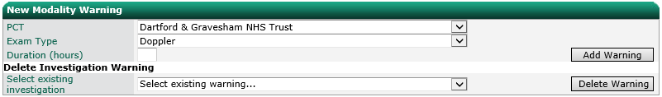
To add a new modality warning, select a Trust or PCT from the PCT drop down list. Select an exam type (modality) and enter an interval in hours. Click Add Warning to save. To delete an existing warning, select the exam type from the drop down list and click Delete Warning.

Investigation Warnings
Pop up warning boxes can be displayed on submitting an order when a user has added a Radiology investigation to an order that has been requested within a pre-defined timescale, for example, to prevent excessive requesting.
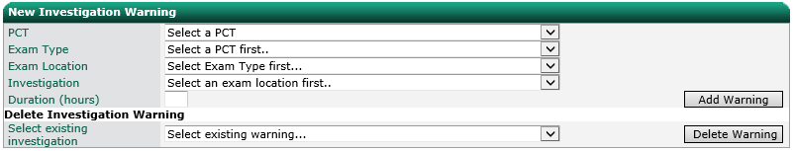
To add a new investigation warning, select a Trust or PCT from the PCT drop down list. Select an exam type (modality), exam location and investigation. Select one or more investigations to link and click OK to save or Cancel to cancel. To modify an existing linked investigation, select the test from the drop down list and click Edit or click Delete to delete.

Linked Investigations
Additional investigations can be automatically added to an order when a particular investigation is added.
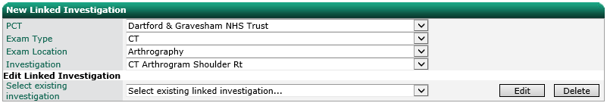
To add a new linked investigation, select a Trust or PCT from the PCT drop down list. Select an exam type (modality), exam location and investigation. Select one or more tests to link and click OK to save or Cancel to cancel. To modify an existing linked test, select the test from the drop down list and click Edit or click Delete to delete.

Mutually Exclusive Investigations
Constraints can be added to prevent two similar investigations from being added to the same order.
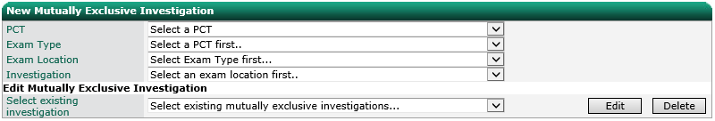
To add a new mutually exclusive investigation, select a Trust or PCT from the PCT drop down list. Select an exam type (modality), exam location and investigation. Select one or more tests to link as mutually exclusive and click OK to save or Cancel to cancel. To modify an existing mutually exclusive test, select the test from the drop down list and click Edit or click Delete to delete.

Test Guidance
Pop up information boxes can be displayed each time a user adds an investigation to an order, for example, to provide useful information.
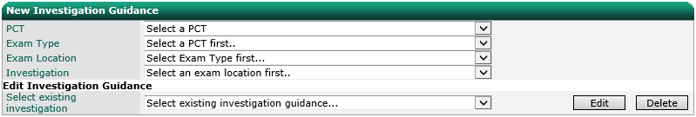
To add guidance for an investigation, select a Trust or PCT from the PCT drop down list. Select an exam type (modality), exam location and investigation. Enter the text to display. If the guidance is to be printed on the form, tick the box and enter the text you wish to print. Click OK to save or Cancel to cancel.
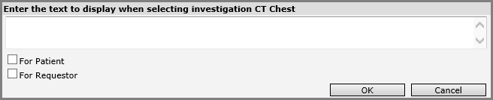

Note – links to an external site can also be included in the guidance. It should follow the standard HTML anchor tag format for example: <a target='_blank' href='http://bbc.co.uk'>Click Here</a>.
To modify existing guidance, select the investigation from the drop down list and click Edit or click Delete to delete.

Investigation Gender Constraint
Constraints can be added to prevent an investigation from being requested for a patient with a particular gender, for example, a prostate ultrasound for a female patient.
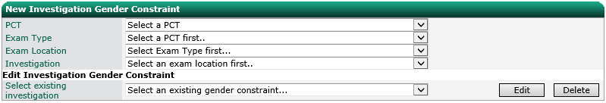
To add a new gender constraint, select a Trust or PCT from the PCT drop down list. Select an exam type (modality), exam location and investigation. Select the gender to which the investigation applies and click OK to save or Cancel to cancel. To modify an existing gender constraint, select the investigation from the drop down list and click Edit or click Delete to delete.

Test Age Constraint
Constraints can be added to prevent an investigation from being requested for a patient between particular ages, for example, investigations not relevant for paediatric patients.
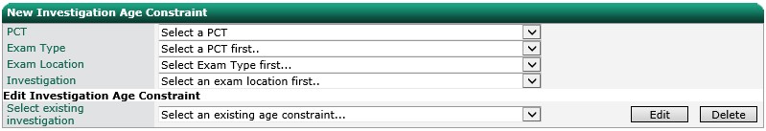
To add a new age constraint, select a Trust or PCT from the PCT drop down list. Select an exam type (modality), exam location and investigation. Enter the age range to which the investigation applies and click OK to save or Cancel to cancel. To modify an existing age constraint, select the investigation from the drop down list and click Edit or click Delete to delete.

Auditing

Requests
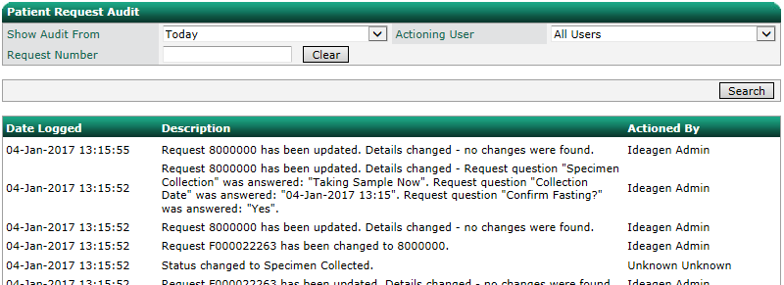
The requests audit displays all interactions with request on the system. The list can be filtered by date range, user and request number. The date and user columns can be sorted.

Results
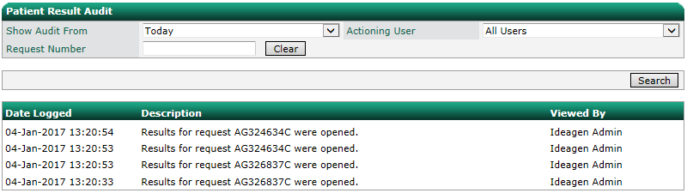
The results audit displays all viewed/opened results. The list can be filtered by date range, user and request number. The date and user columns can be sorted.

Confidential
The confidentiality audit displays all modifications to a patient’s confidential status, views of requests and records for patients marked as confidential. The list can be filtered by date range, user and patient number. The date and patient columns can be sorted.
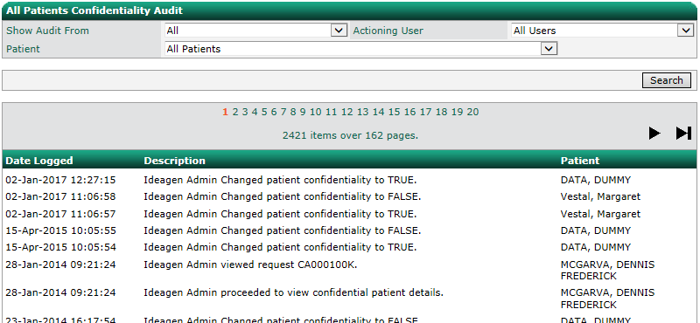
Note – only patients marked as confidential are listed in the “Patient” drop down list.

Users
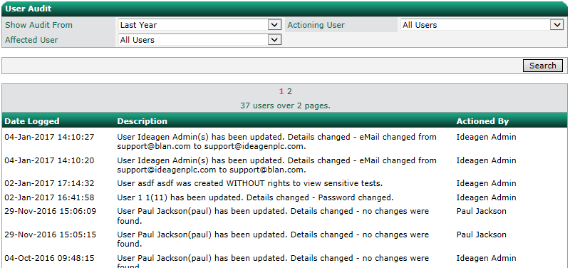
The users audit displays all modifications to user records. The list can be filtered by date range, user and affected user record. The date and user columns can be sorted.

Sign Off
The sign off audit displays all sign off actions including when a user notes that they opened the results in error (instead of signing off), and when a user navigates away from the page using the browser back button, bypassing the sign off prompt. The list can be filtered by date range, user and request number. The date and user columns can be sorted.

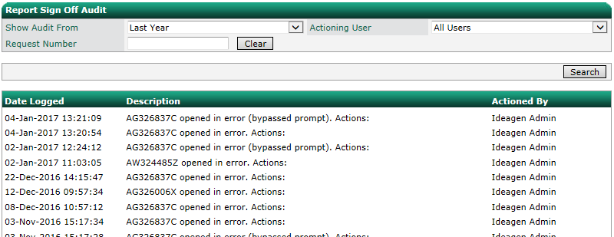

Notifications
The notifications audit displays the transmission of all notification messages. The list can be filtered by date range, receiving user and request number. The date and user columns can be sorted.

Appendix I – Permissions Matrix

Auditing Permissions
Permission | Access To
Auditing – Notifications | Configuration > Auditing > Notifications
Auditing – Patient Confidentiality | Configuration > Auditing > Confidential
Auditing – Patients | Patient Summary / Actions > Patient Audit
Auditing – Requests | Configuration > Auditing > Requests
Auditing – Results | Configuration > Auditing > Results
Auditing – Sign Off | Configuration > Auditing > Sign off
Auditing – Users | Configuration > Auditing > Users

Cardiology Permissions
Permission | Access To
Cardiology Questions | Configuration > Requests Config > Questions (Cadiology Tab)

Configuration Permissions
Permission | Access To
Password Policy | Configuration > Password Policy
Change Password | Configuration > Change Password
My Patients | Configuration > Patient Management > My Patients
Notifications | Configuration > Notifications
Patient Merge | Configuration > Patient Management > Patient Merge
Specimen Number Management | Configuration > Specimen Numbers

Favourite Tests Permissions
Obsolete – do not use.

Laboratory Related Permissions
Permission | Access To
Cardiology Lab Printing | Main Menu > Cardiology Printing
Phlebotomy Printing | Main Menu > Phlebotomy Printing
Quick Submit Cytology | Obsolete – do not use
Radiology Lab Printing | Main Menu > Radiology Printing
Quick Submit Histology | Obsolete – do not use
Quick Vetting Radiology | Obsolete – do not use

Lookup Management Permissions
Permission | Access To
Antibiotic Therapies Management | Configuration > Lookup Management > Antibiotic Therapies
Clinical Details Management | Configuration > Lookup Management > Clinical Details
Discipline Management | Configuration > Lookup Management > Disciplines
Patient Category Management | Configuration > Lookup Management > Patient Categories
Specimen Site Management | Configuration > Lookup Management > Specimen Sites
Specimen Type Management | Configuration > Lookup Management > Specimen Types

Main Menu Permissions
Permission | Access To
Alerting | Main Menu > Alerting
Cross Discipline Order Request | Main Menu > New Order Request
EWard Search Page | Main Menu > EWard Search Page (if applicable)
Home | Main Menu > Home
iLab Reports | Main Menu > Telepath Reports (if applicable)
Links | Main Menu > Links
News | Main Menu > News
OCM Search | Main Menu > Search
Reception | Main Menu > Reception

Order Request Permissions
Permission | Access To
Process Order | Main Menu > Process Orders

Patient Management Permissions
Permission | Access To
Patient Data Transfer | Configuration > Patient Management > Patient Data Transfer

“Permissions” Permissions
Permission | Access To
Email Permissions | Configuration > Permissions > Email
Emailing of results | Obsolete – do not use
User Type Permissions | Configuration > Permissions > Access

Print Settings Permissions
Permission | Access To
Machine Print Management | Configuration > Print Settings > By Machine
Print Management | Configuration > Print Settings > By Location

Radiology Permissions
Permission | Access To
Manage Radiology Examination Permissions | Configuration > Radiology > Exam Permissions
Radiology Investigation Management | Configuration > Radiology > Investigation Management
Radiology Location Examinations | Configuration > Radiology > Location Exams
Radiology Questions | Configuration > Requests Config > Questions (Radiology Tab)
Radiology Rules Management | Configuration > Radiology > Rules

Request Config Permissions
Permission | Access To
Import / Export | Configuration > Request Config > Import / Export
Request Process Actions | Configuration > Request Config > Process Actions
Request Questions | Configuration > Request Config > Questions

Requests Permissions
Permission | Access To
Cardiology Request | Allows the user to order Cardiology investigations
Cytology Request | Allows the user to order Cytology tests
Histology Request | Allows the user to order Histology investigations
Patient Test Request | Allows the user to order other Pathology tests (Chemistry, Haematology, Immunology, Coagulation, Microbiology)
Radiology Request | Allows the user to order Radiology investigations
Tolerance Test Request | Allows the user to order other tolerance tests

Results Permissions
Permission | Access To
Blood Transfusion Reports | Allows the user to view Blood Transfusion results
Cardiology Reports | Allows the user to view Cardiology reports
Cumulative Results | Patient Summary Screen > Cumulative Results
Histology Reports | Allows the user to view Histology reports
Microbiology reports | Allows the user to view Microbiology results
Pathology Results | Allows the user to view Pathology results (Chemistry, Haematology, Immunology, Coagulation, Microbiology)
Radiology Reports | Allows the user to view Radiology reports

Standard Reports Permissions
Permission | Access To
Domiciliary Lab Printing | Main Menu > Domiciliary Printing
Overdue Report | Standard Reports > Actions > Missing Specimen Report
Patients by Test Report | Standard Reports > Actions > Patient by Test Report
Phlebotomy Report | Standard Reports > Actions > Phlebotomy Report
Request Count Reports | Standard Reports > Actions > Request Count Reports
Requested Tests Report | Standard Reports > Actions > Requested Tests Report
Requests by Requestor Report | Standard Reports > Actions > Requests by Requestor Report
Result Read Receipt | Standard Reports > Actions > Result Read Report

Test Selection Permissions
Permission | Access To
Assign Tests to User Types | Configuration > Test Management > Test user Type Assignment
Cross Specimen Requesting | Obsolete – do not use
Define Sensitive Tests | Configuration > Test Management > Sensitive Tests
Manages Test Questions | Configuration > Request Config > Test Questions (add, modify, and delete)
Rules Management | Configuration > Test Management > Rules
Test Management | Configuration > Test Management > Test

Test Selection Permissions
Permission | Access To
Global Favourites | Configuration > Test Lists > Global Order Lists
Investigations | Configuration > Test Lists > Investigations
Location Favourites | Configuration > Test Lists > Location Order Lists
My Favourites | Configuration > Test Lists > My Orders Lists

User Management Permissions
Permission | Access To
Location Management | Configuration > User Management > Locations
Requestors Management | Configuration > User Management > Requestors
User Management | Configuration > User Management > Users
User Types | Configuration > User Management > User Types

Appendix II – LIMS Reports
Note – only available on certain implementations.
The Laboratory Information Management System (LIMS) Reports screen allows administrators to monitor the requests that have been successfully submitted, errored during submittal or in a pending status. It is accessed via the right hand main menu. The actual title of the menu item will vary depending on the lab system used e.g. “Apex Reports” or “TelePath Reports”.

Unsuccessful Requests
By default, the screen will display a list of unsuccessful requests.
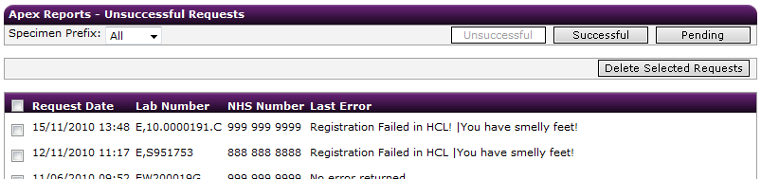

Requests can be filtered by prefix by changing the drop down Specimen Prefix. The error returned by the LIMS is displayed in the Error Description field. Clicking on the row will take you to the main request screen where you can amend the request and resubmit.
To remove a request from the view, tick the relevant check boxes and click Delete Selected Requests.
Note – requests are not actually deleted from the system.

Successful Requests
To view successfully submitted requests click the Successful radio button. This view is for information only. Once successfully submitted a request can’t be changed. Clicking on a row will show the request in the main request screen.
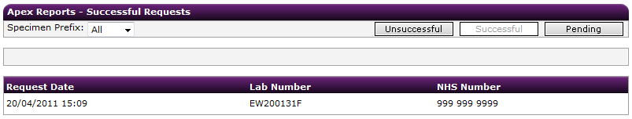

Pending Requests
The pending request view displays requests at various statuses.
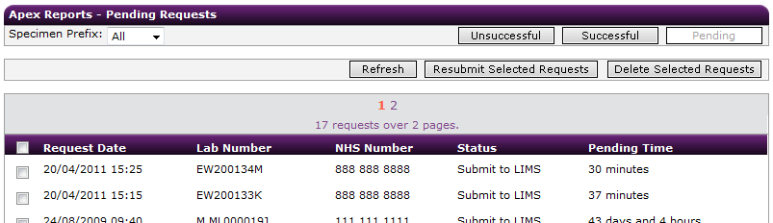

A request can be submitted once it has reached the “Request Submitted By Doctor” or “Specimen Collected” status. The submittal steps and associated statuses are detailed below.
File based interface:
- Request submitted via the Process Orders screen. Status changed to “Submit to LIMS”. At this point the request has only been modified in the database to say that it can be submitted.
- The Ideagen OCM service processes requests in status “Submit to LIMS”. The service generates the order file and places it in the pickup folder. Once the file is placed the request status is changed to “Submitted”.
- The LIMS processes the file and places a response file in the pickup folder. No status change is recorded in Ideagen OCM.
- The Ideagen OCM service processes the LIMS response file. The requests status is changed to “Order Accepted” or “Error in order” depending on the content of the response file.
TCP/IP based interface:
- Request submitted via the Process Orders screen. Status changed to “Submit to LIMS”. At this point the request has only been modified in the database to say that it can be submitted.
- The Ideagen OCM service processes requests in status “Submit to LIMS”. The service generates a network message and sends it straight to the LIMS interface connection. Once the data is passed over the request status is changed to “Submitted”.
- When the LIMS has received the data, it responds with an acknowledgement message. The request status is changed to “Acknowledgement Received”. At this point the LIMS has the data, but has not processed it yet.
- The LIMS processes the data and sends a network message directly to the Ideagen OCM service. The requests status is changed to “Order Accepted” or “Error in order” depending on the content of the message.
If a request is stuck in a status due to a failure at some point, it can be resubmitted by tick the relevant check boxes and clicking Resubmit Selected Requests. This will reset the status to “Submit to LIMS”.
To remove a request from the view, tick the relevant check boxes and click Delete Selected Requests.
Note – requests are not actually deleted from the system.

